Kapture - DMT (Data Migration Tool) Unit Test Cases

Contents
1. User System Access 2
2. Settings 4
3. Meta Data Validation 6
4. Master Data Syncing 11
5. Folder Based Content Load (Conversion) 19
6. Conversion and Scheduling Validation Rules 26
7. History and Reports 40
8. Preview and Publish 46
9. IPM Facelift VIN Update 49

Kapture - DMT (Data Migration Tool)
Unit Test Cases
Application URL: https://na.dev.mgss.oc.mazda.com/dmtgt
Application: dmtgt.war (/dmtgt) | Version: v2 | Date: 16-Oct-2026
- Unit Test Case Summary:
# | Test Cases Processes | No. of Test Cases | No. of Success | No. of Failure | Status
1 | User System Access | 2 | 2 | 0 | Pass
2 | Settings | 2 | 2 | 0 | Pass
3 | Meta Data Validation | 3 | 3 | 0 | Pass
4 | Master Data Syncing | 4 | 4 | 0 | Pass
5 | Folder Based Content Load (Conversion) | 5 | 5 | 0 | Pass
6 | Conversion and Scheduling Validation Rules | 14 | 14 | 0 | Pass
7 | History and Reports | 4 | 4 | 0 | Pass
8 | Preview and Publish | 2 | 2 | 0 | Pass
9 | IPM Facelift VIN Update | 4 | 4 | 0 | Pass
 | Total | 40 | 40 | 0 | Pass

User System Access
- User should be able to log in to DMT using the application URL.
Steps:
1. Log in to MGSS with a valid user.
2. Open the URL: https://na.dev.mgss.oc.mazda.com/dmtgt
Expected Result: The DMT Settings page opens with the top menu Settings, Schedule, History, Meta Data Validation, Master Data Syncing and Logout.
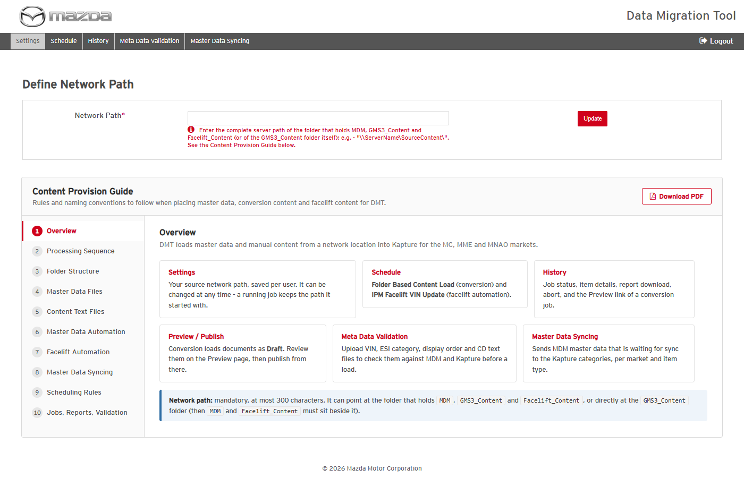
DMT Settings page after login
Status: Pass
Remarks:

- User without an active Kapture user profile should not be able to use DMT.
Steps:
1. Log in with a MGSS user that has no active Kapture user profile and open the DMT URL.
Expected Result: "You do not have enough permission to access this application. Please contact MGSS Support." is displayed; no DMT screen is available.
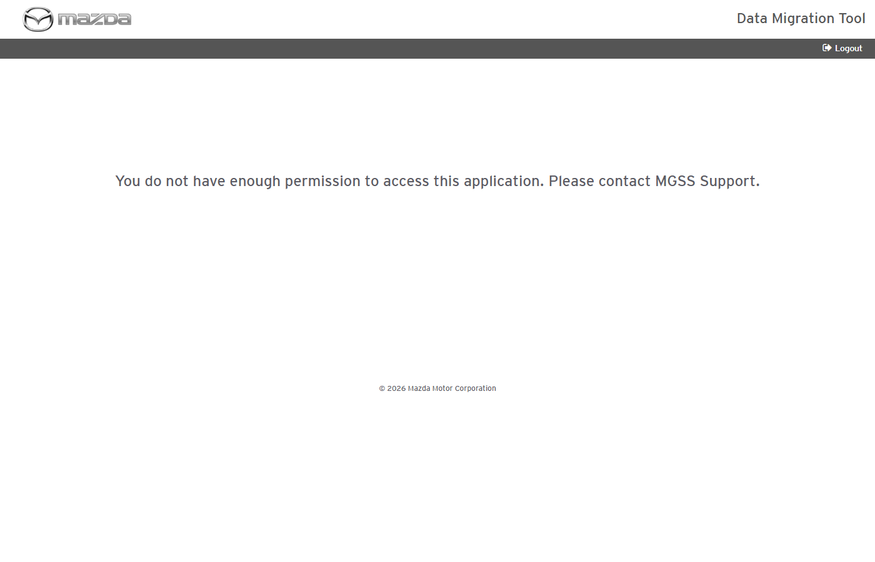
No-access page
Status: Pass
Remarks:

Settings
- User should be able to define / update the source Network Path.
Steps:
1. Open Settings and enter the path of the folder that holds MDM, GMS3_Content and Facelift_Content.
2. Click Save (first time) or Update.
Expected Result:
- "Network Path updated successfully." (or saved successfully) is shown and the path is displayed.
- The path can be changed at any time - a job that is already running keeps the path it started with.
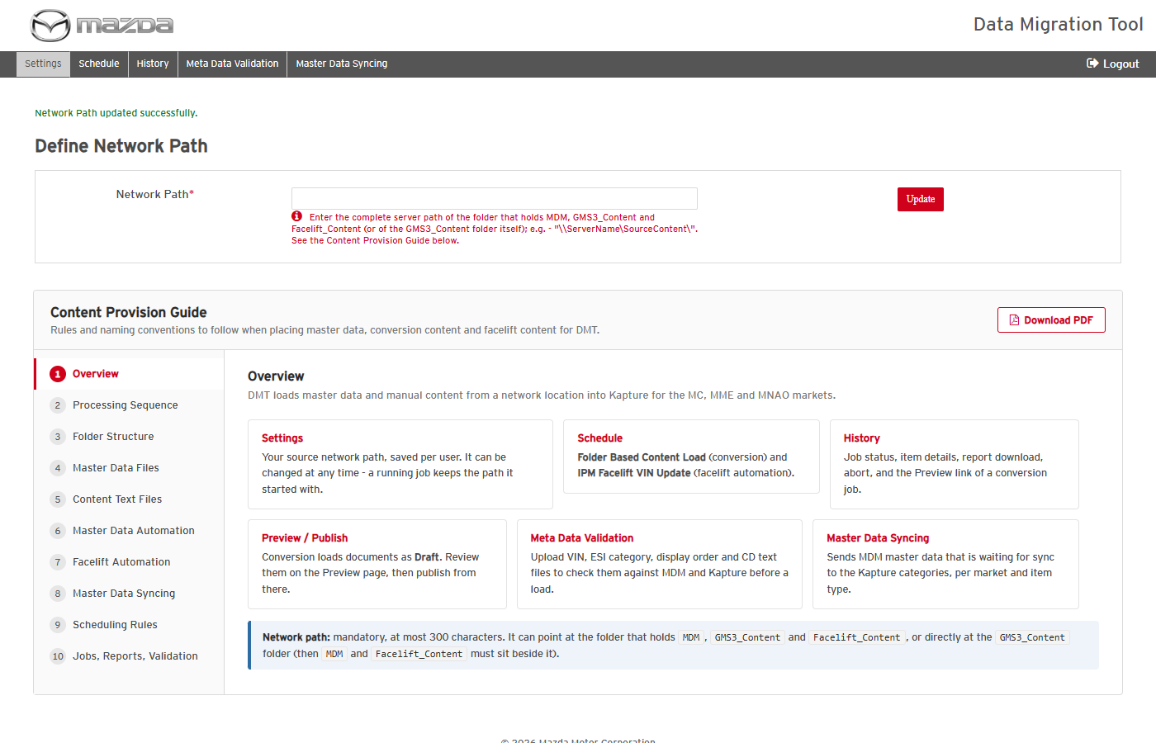
Network Path updated
Status: Pass
Remarks:

- User should be able to read the Content Provision Guide and download it as PDF.
Steps:
1. On Settings click through the 10 guide tabs (e.g. Scheduling Rules).
2. Click Download PDF.
Expected Result: Each tab shows its rules and examples; the complete guide is downloaded as a PDF.
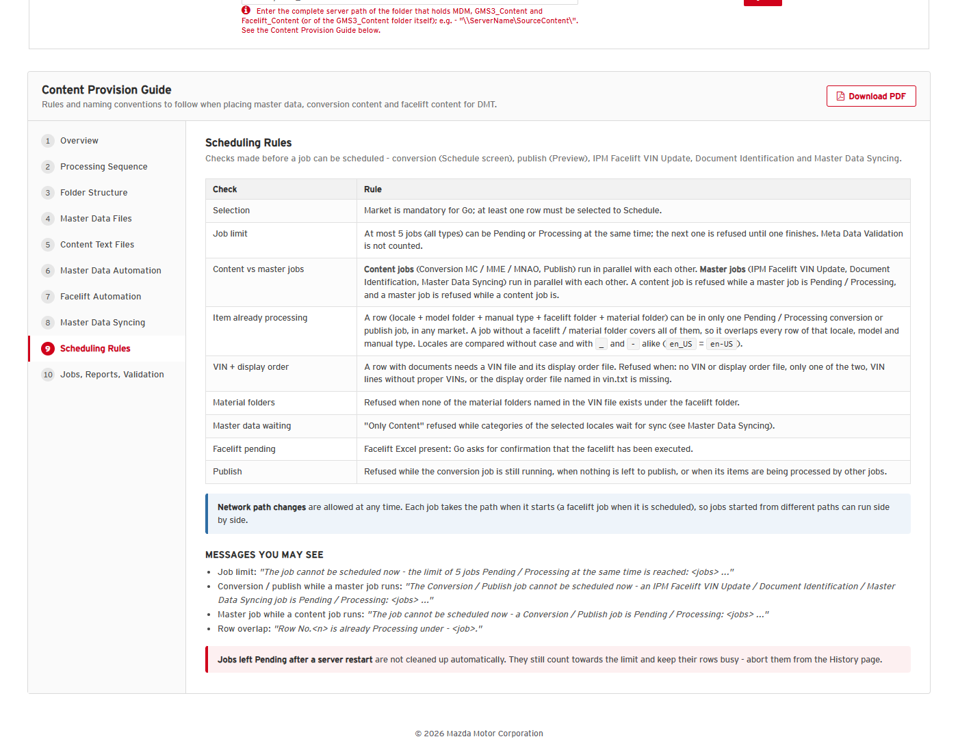
Content Provision Guide - Scheduling Rules tab
Status: Pass
Remarks:

Meta Data Validation
- User should be able to validate a VIN / ESI / display order / CD text file before a load.
Steps:
1. Open Meta Data Validation; select Country (e.g. Japan) and Language (ja-JP).
2. Select the MetaData Type (e.g. VIN), choose the file (vin.txt) and click Upload.
3. Click Validate and refresh until the schedule is finished.
Expected Result:
- "MetaData Validations scheduled successfully." is shown.
- The schedule ends with Lines Total / Processed / Failed and Status (e.g. 4 / 4 / 0 Success); the report lists every invalid line with its reason.
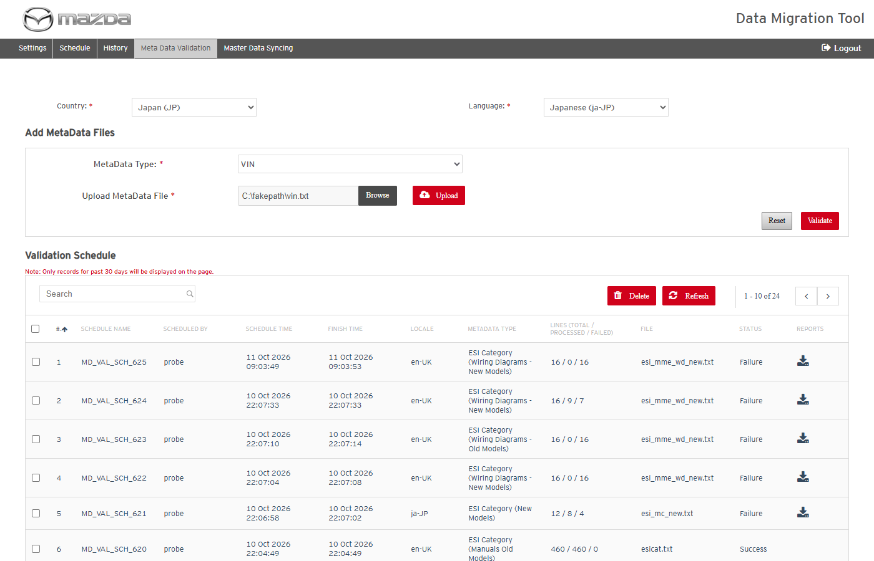
Country, language, type and file selected
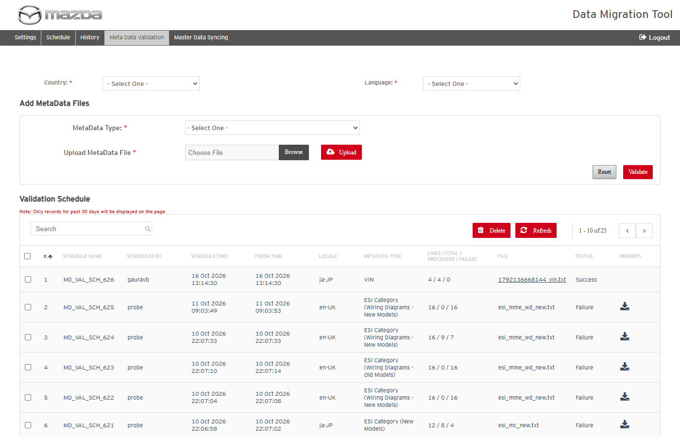
Validation schedule completed
Status: Pass
Remarks:

- System should reject a metadata file with a wrong name.
Steps:
1. Select type VIN and upload a file whose name does not start with vin (e.g. test.txt).
Expected Result: "File test.txt is invalid. Please upload a valid Text file." is shown and nothing is uploaded.
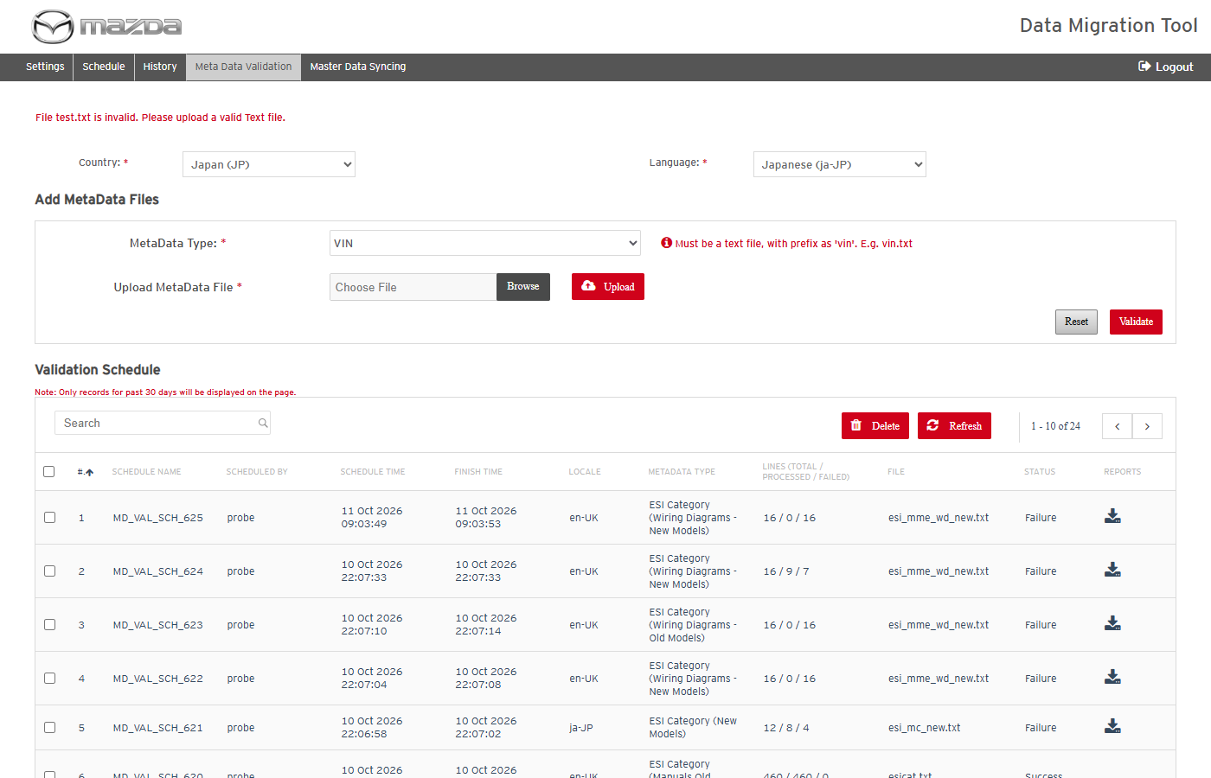
Wrong file name rejected
Status: Pass
Remarks:

- User should be able to delete validation schedules.
Steps:
1. Select a validation schedule, click Delete and confirm with Yes.
Expected Result: "Meta Data Schedule(s) deleted successfully." is shown and the schedule is removed from the list.
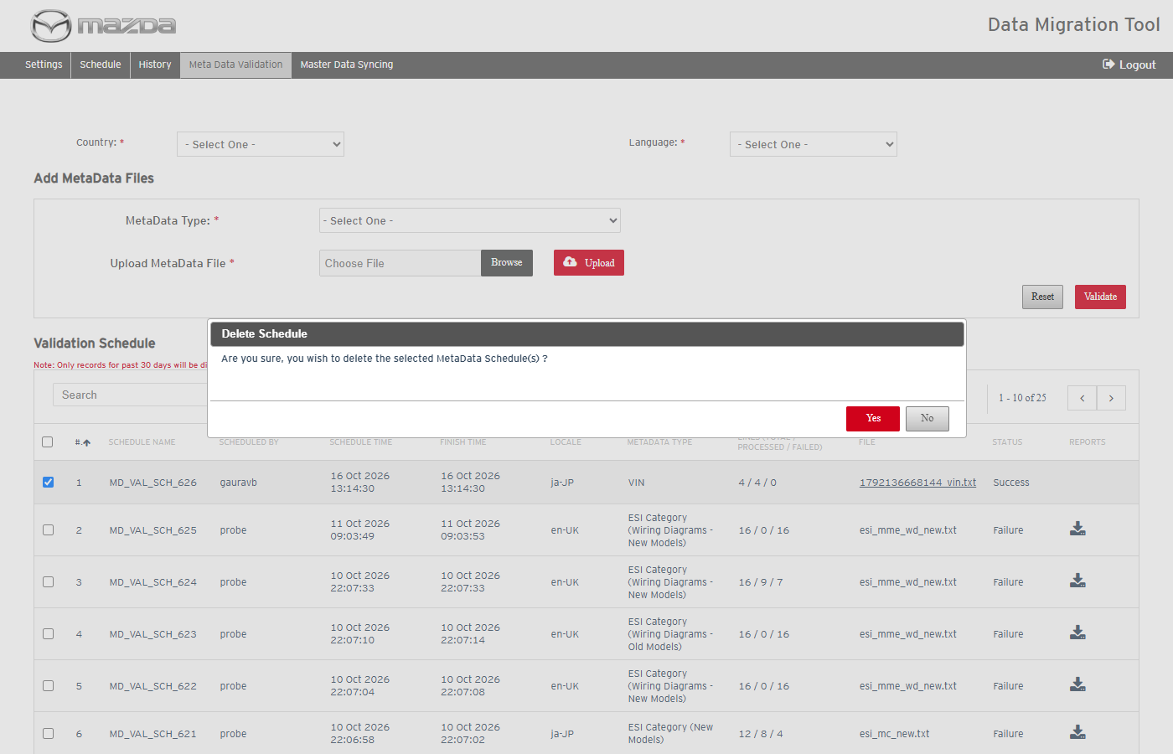
Delete confirmation
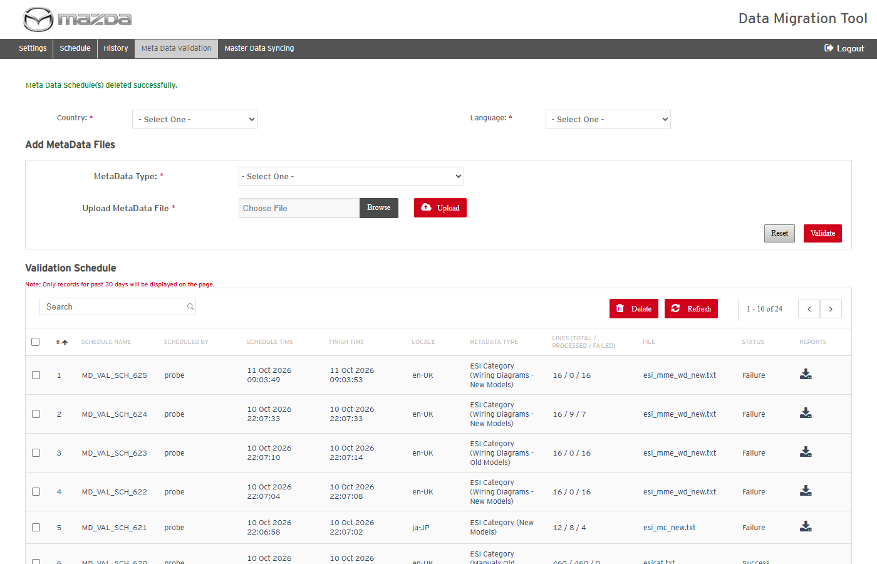
Delete result
Status: Pass
Remarks:

Master Data Syncing
- User should be able to sync MDM master data to the Kapture categories.
Pre-condition: MDM rows waiting for sync exist for the market.
Steps:
1. Open Master Data Syncing, select the Market (e.g. MME), tick All (or the item types) and click Go.
2. Check the items and categories count and click Sync Master Data; confirm with Schedule.
3. Refresh until the schedule is finished; open the schedule details.
Expected Result:
- "MGSS_MDSYNC_<market>_<id> scheduled successfully." is shown.
- The schedule ends Completed / Success with Categories Total / Processed / Failed (e.g. 114 / 114 / 0); the categories are created / updated in Kapture.
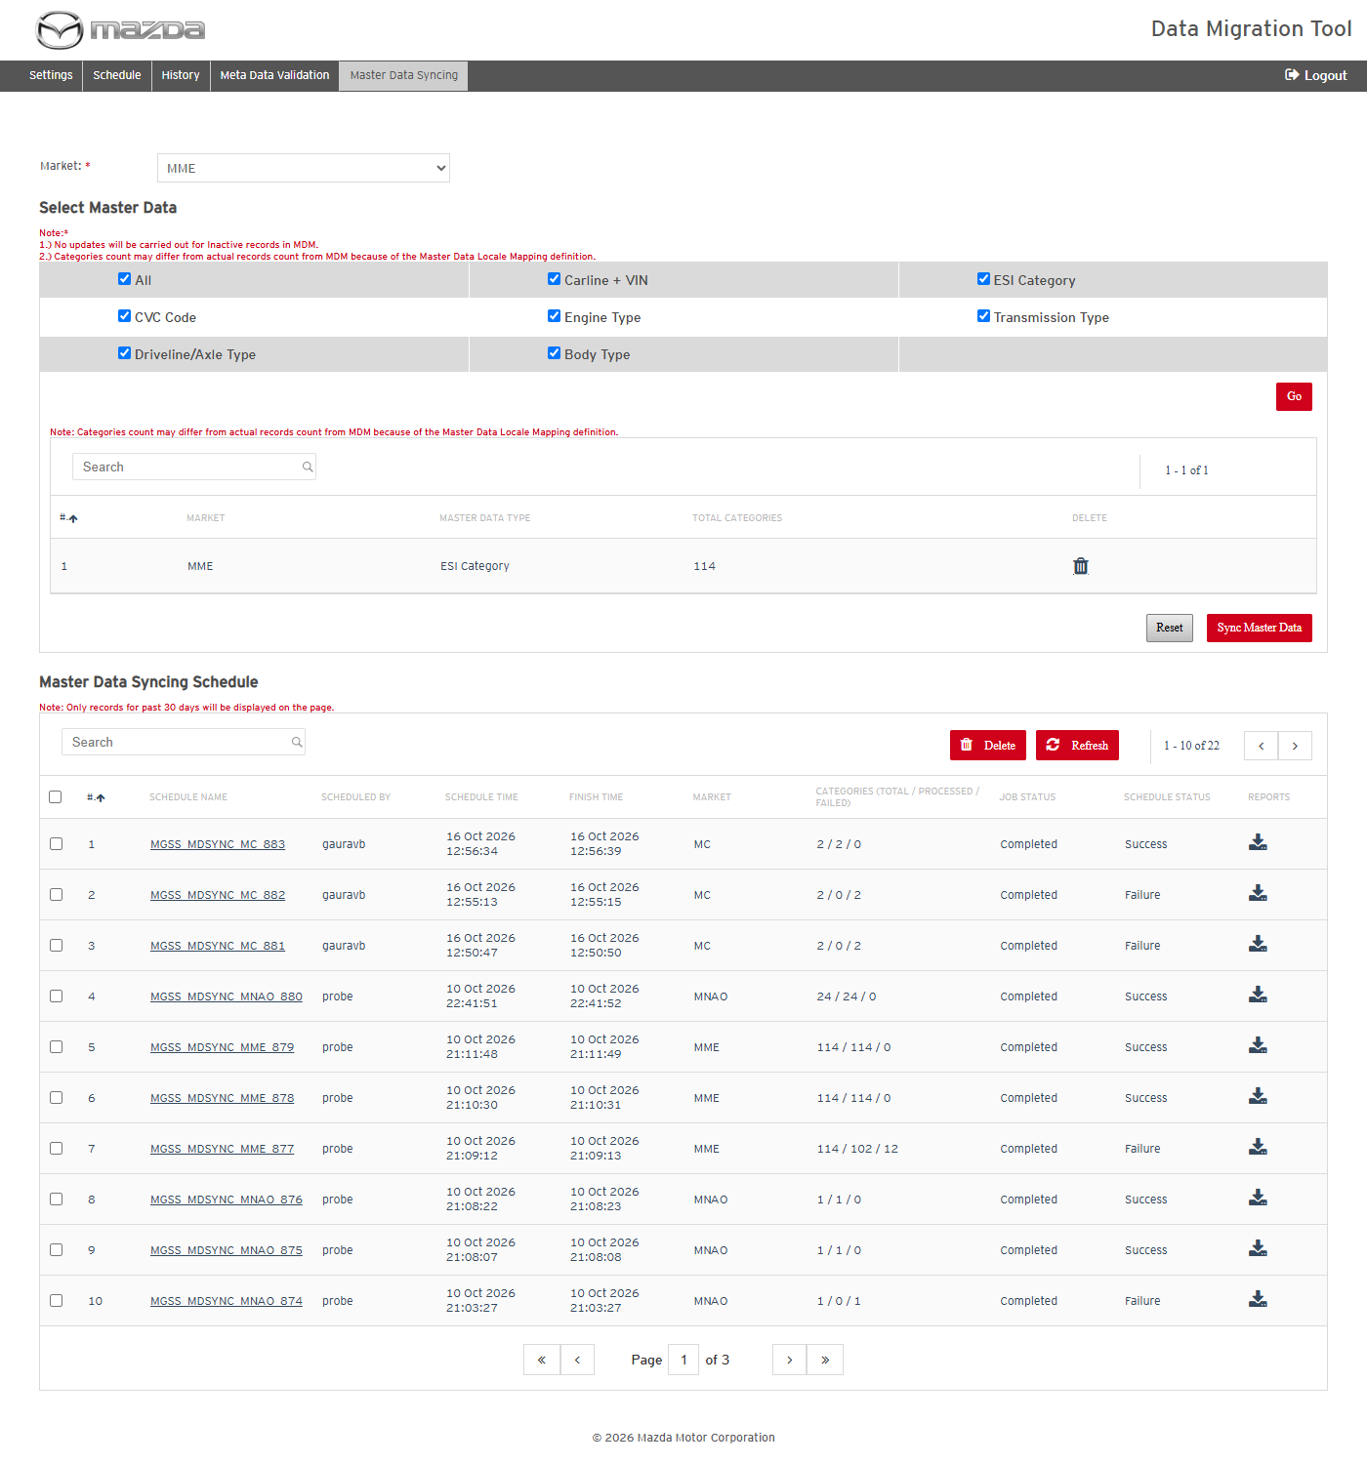
Items waiting for sync after Go
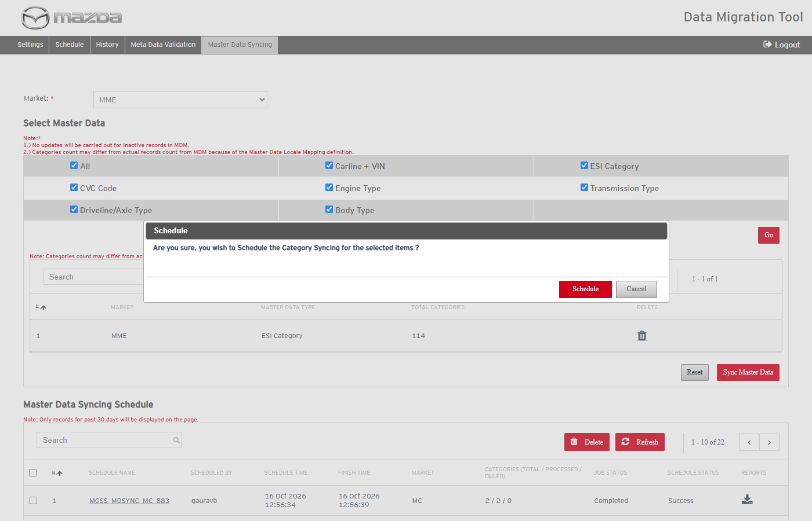
Schedule confirmation
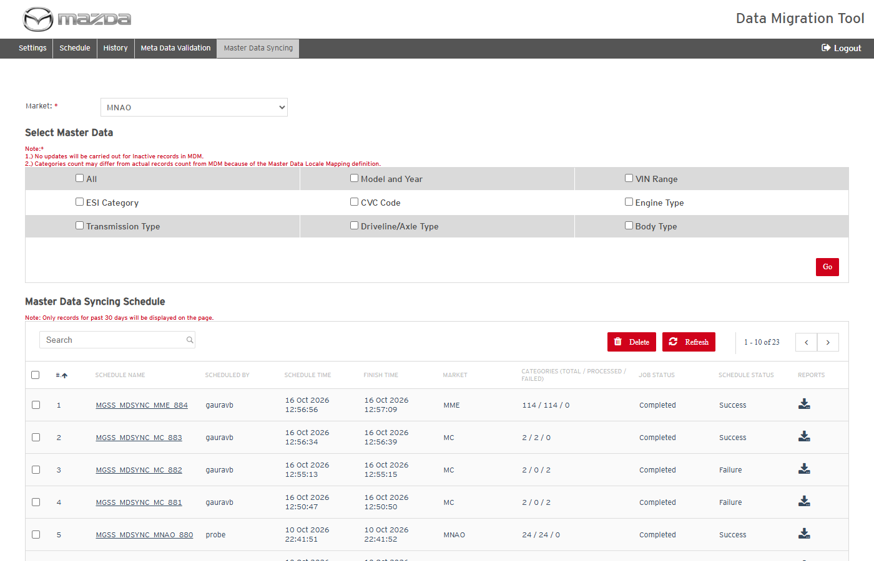
Schedule completed - Success
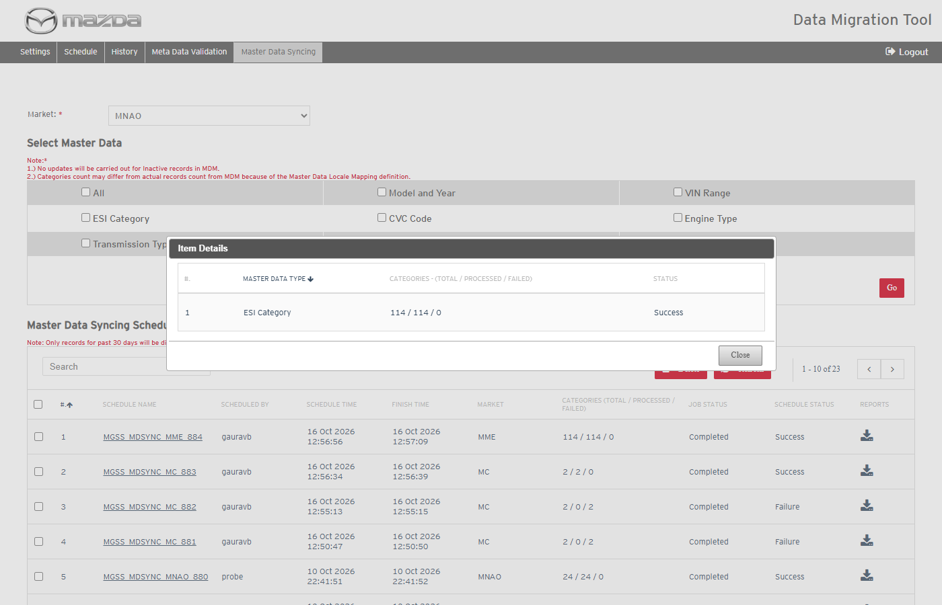
Schedule item details
Status: Pass
Remarks:

- System should not allow Go without a master data selection.
Steps:
1. Select a Market and click Go without ticking any master data type.
Expected Result: "Please select at least one Item to proceed." is shown.
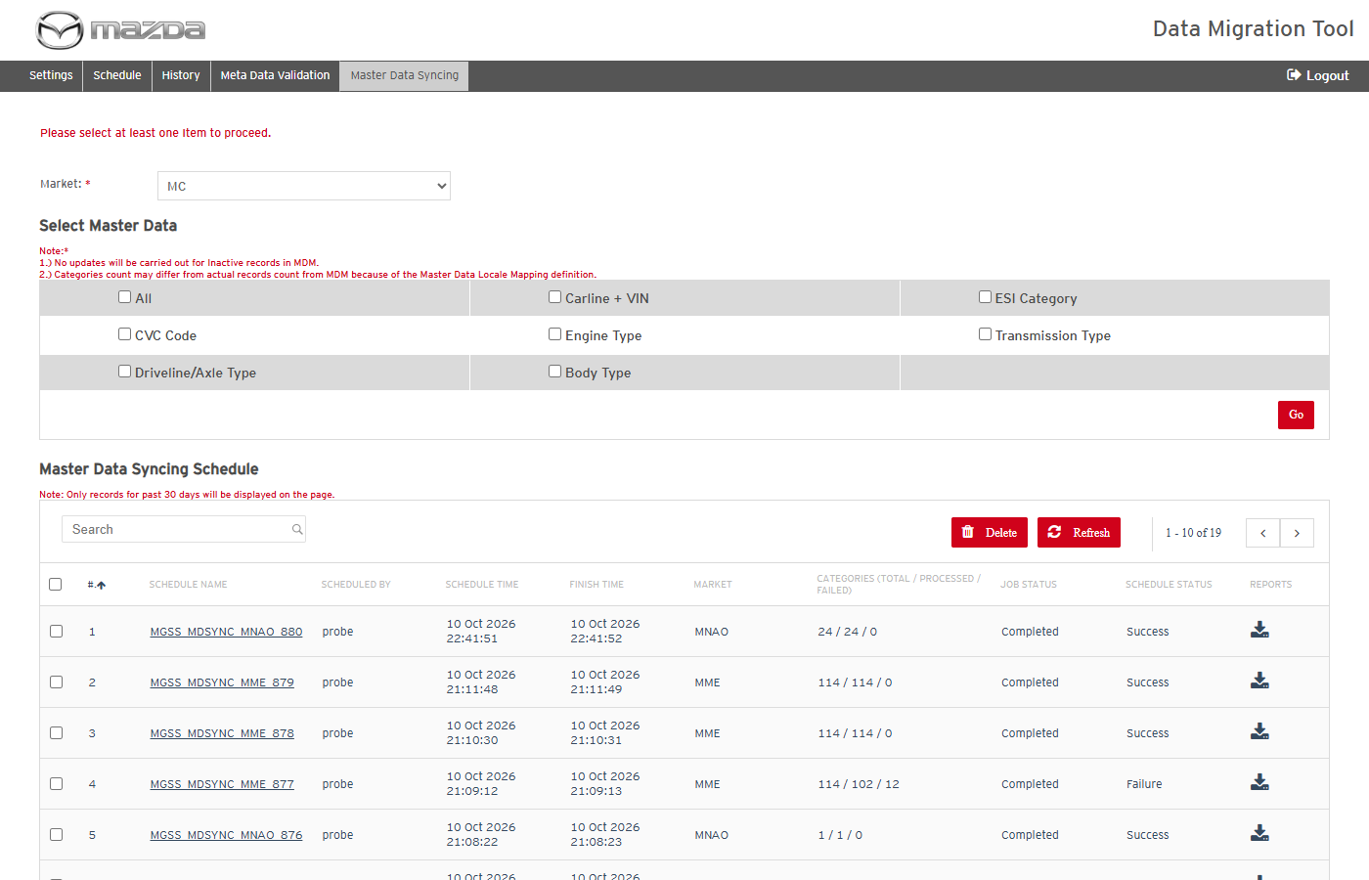
Selection message
Status: Pass
Remarks:

- User should be able to abort a Master Data Syncing schedule that is Processing.
Steps:
1. Click the Abort icon of a Processing schedule and confirm with Abort.
Expected Result: "Category Syncing Schedule aborted successfully." is shown and the job status becomes Aborted.
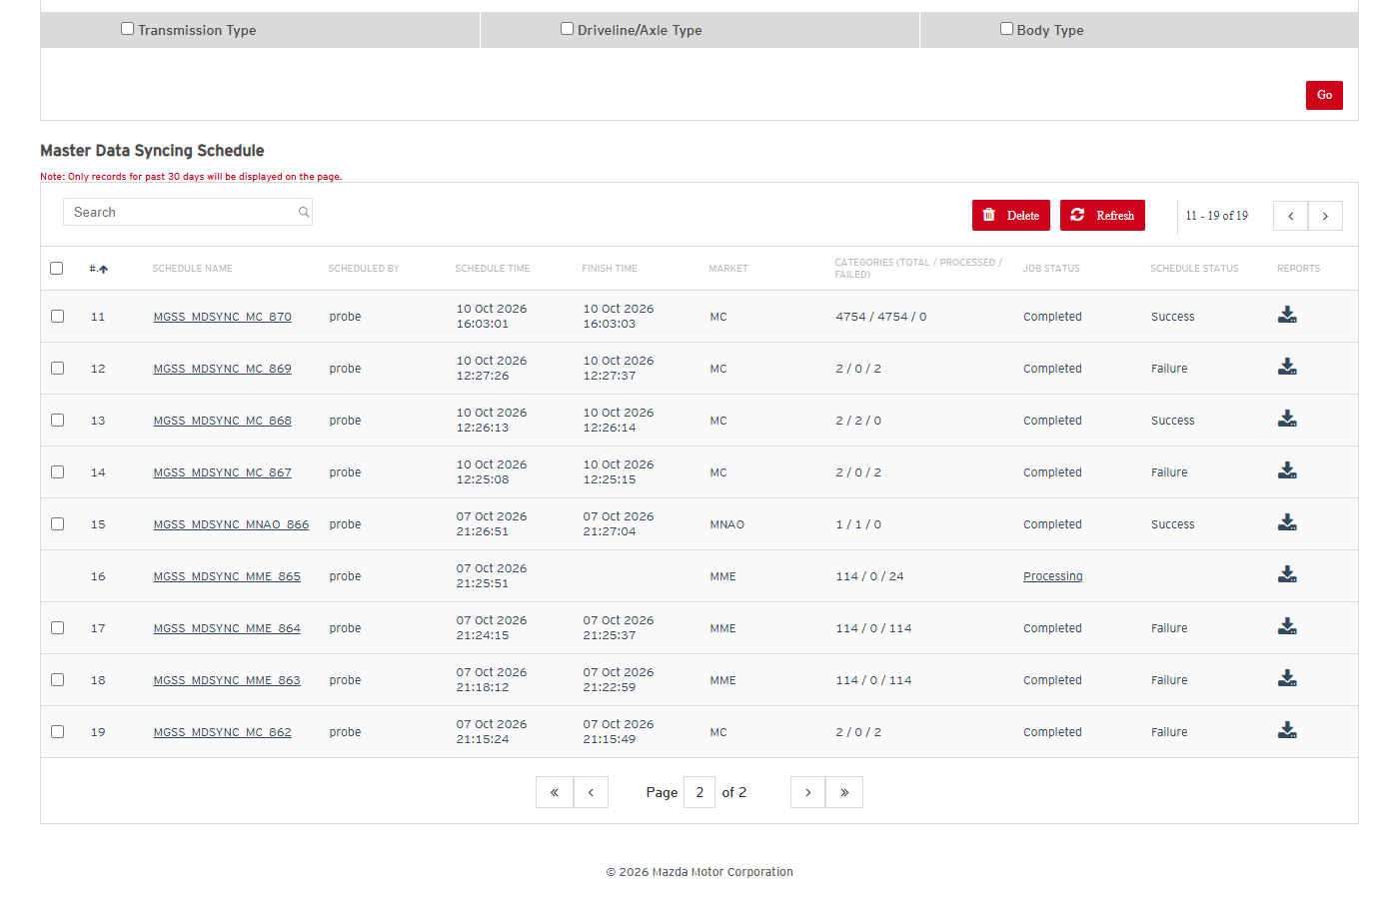
Processing schedule
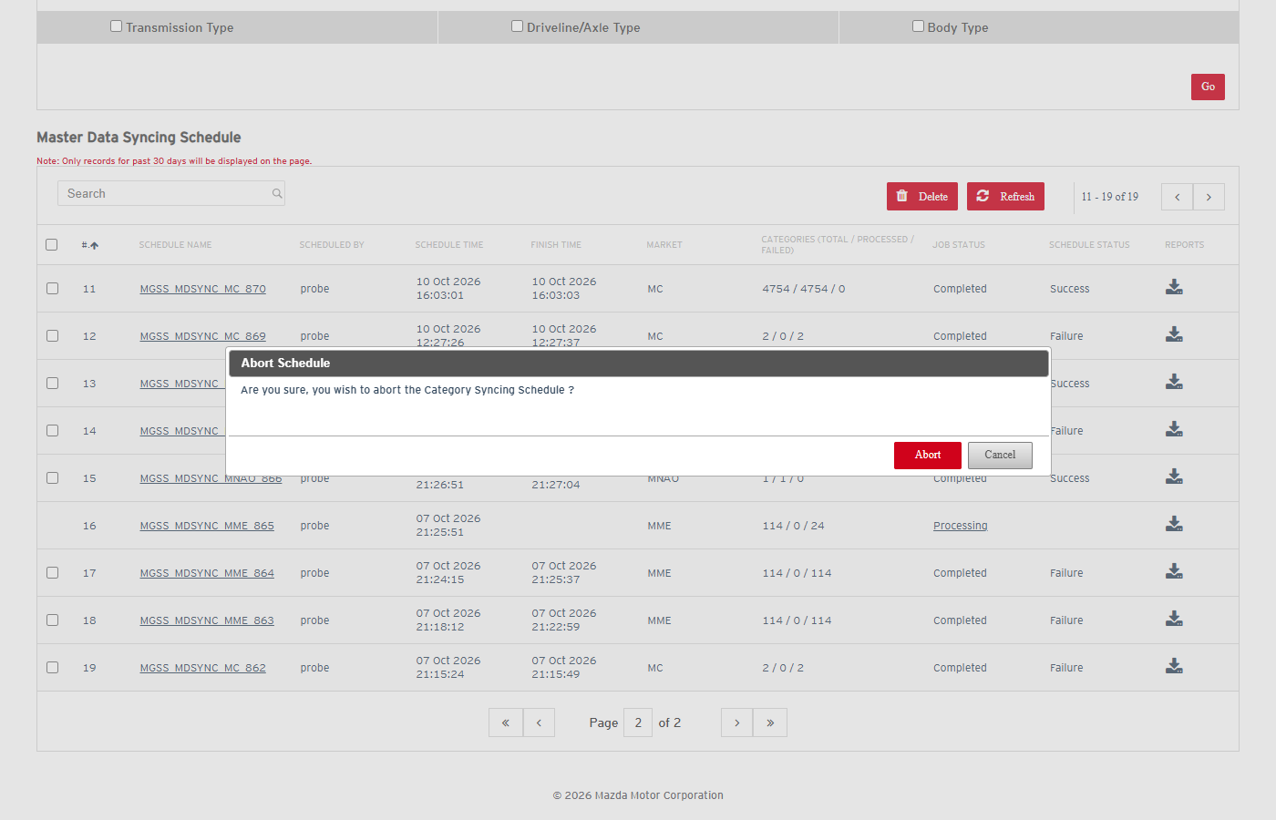
Abort confirmation
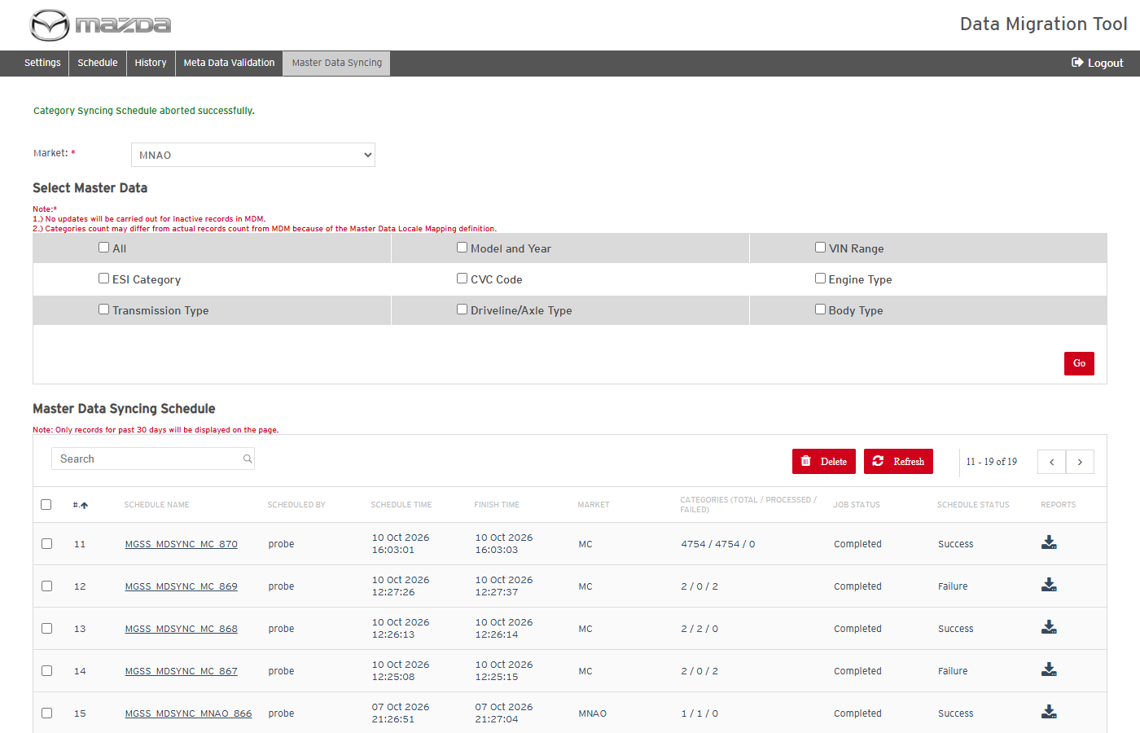
Abort result
Status: Pass
Remarks:

- User should be able to delete Master Data Syncing schedules.
Steps:
1. Click Delete without a selection.
2. Select schedule(s), click Delete and confirm with Yes.
Expected Result:
- Without a selection: "Please select atleast 1 row to delete."
- "Master Data Schedule(s) deleted successfully." and the schedules are removed.
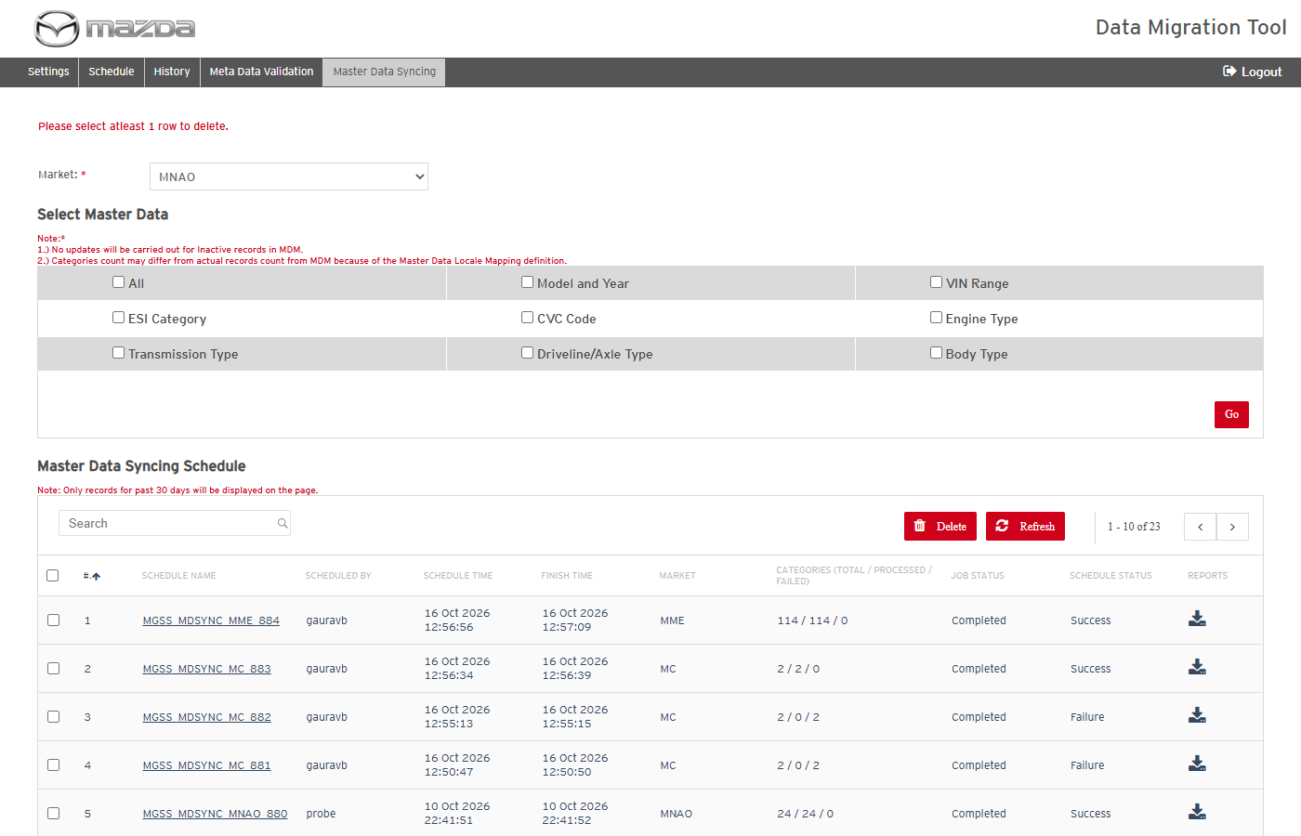
No row selected
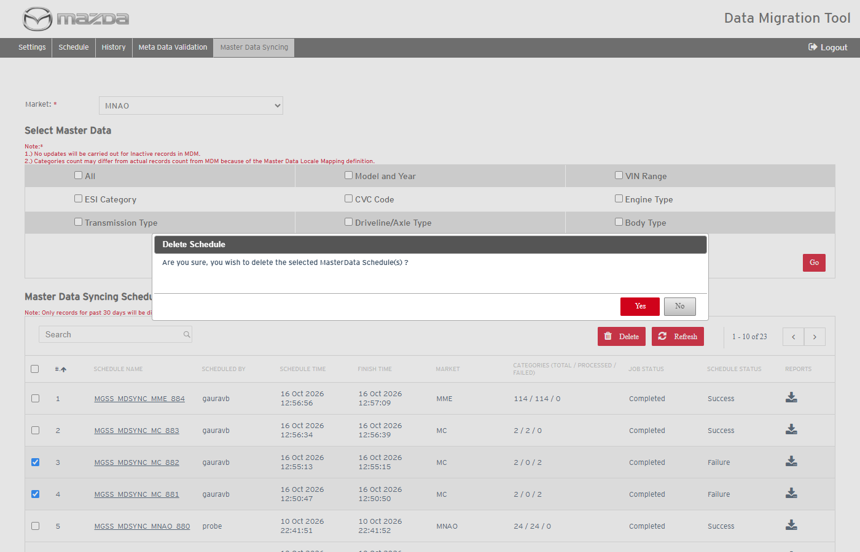
Delete confirmation
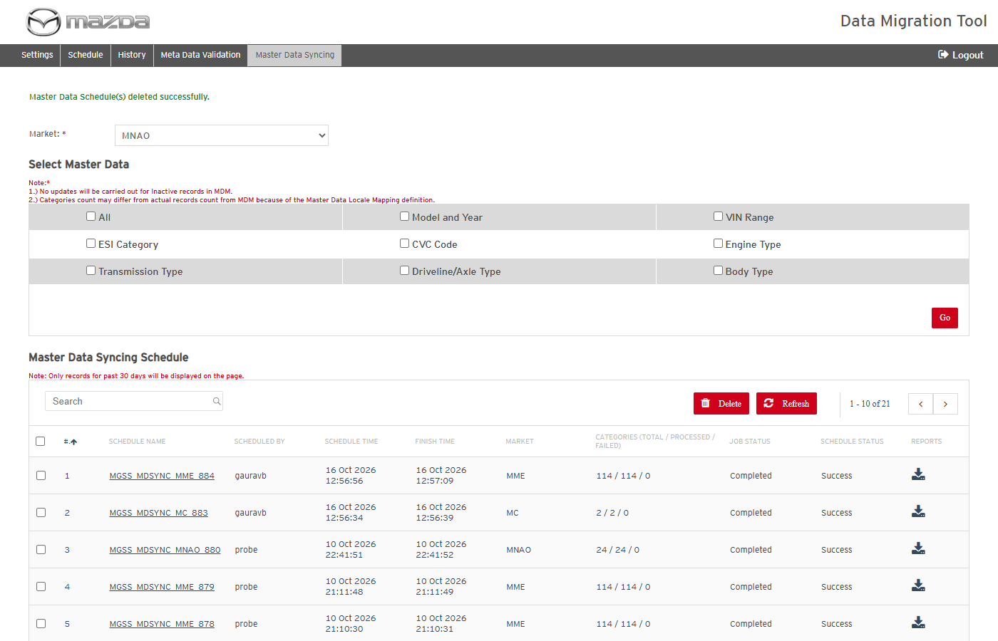
Delete result
Status: Pass
Remarks:

Folder Based Content Load (Conversion)
- User should be able to list the conversion items of the network location.
Steps:
1. Open Schedule, Operation Type Folder Based Content Load.
2. Select Market, Locale, Model(s), Manual Type and click Go.
Expected Result: The items are listed with Material Code Name, Total Docs for OKM Processing, ESI Category / Left Menu Docs, Actual Folder Docs, OKAssets File, Display Order, CD Display Order and SCM VIN Mapping counts, and the Load Type choice (Master Data with Content / Only Content).
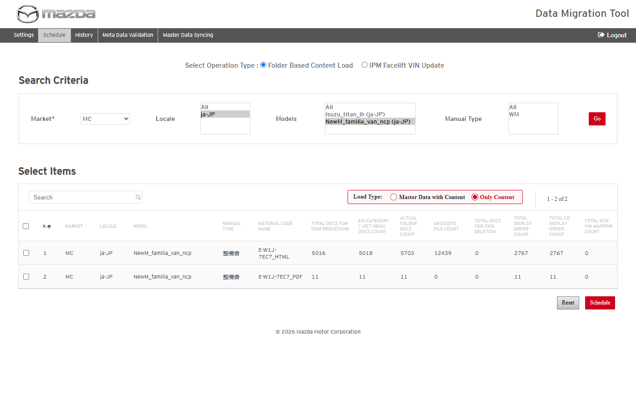
Conversion items after Go
Status: Pass
Remarks:

- System should ask for the facelift run when facelift Excel files are present.
Pre-condition: Excel file(s) are present in the Facelift_Content folder.
Steps:
1. Select the conversion filters and click Go; answer No, then repeat and answer Yes.
Expected Result: "Facelift Content found - ... The IPM Facelift VIN Update ... must be executed before the Conversion. Have you executed it?" is shown; No stops, Yes lists the items.
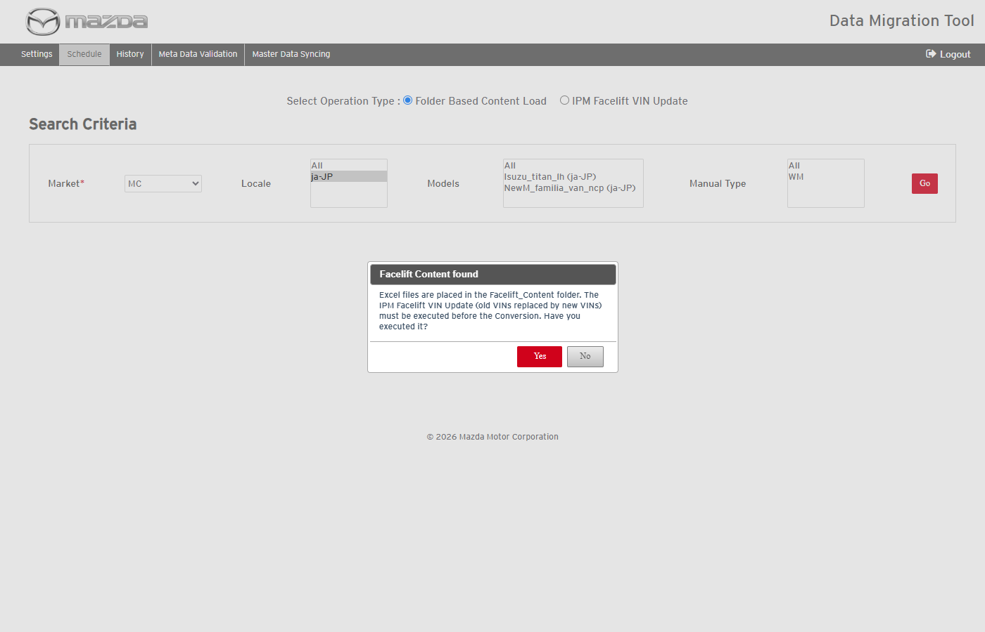
Facelift confirmation at Go
Status: Pass
Remarks:

- User should be able to schedule a conversion (load type Only Content).
Steps:
1. List the items (e.g. MME / en-UK / NewM_BT-50_tf), select a row and keep Load Type Only Content.
2. Click Schedule and confirm with Schedule; follow the job on History.
Expected Result:
- "MGSS_CONV_<market>_<date>_<id> scheduled successfully." is shown.
- The job ends COMPLETED / Success; the documents are created / updated in Kapture as Draft.
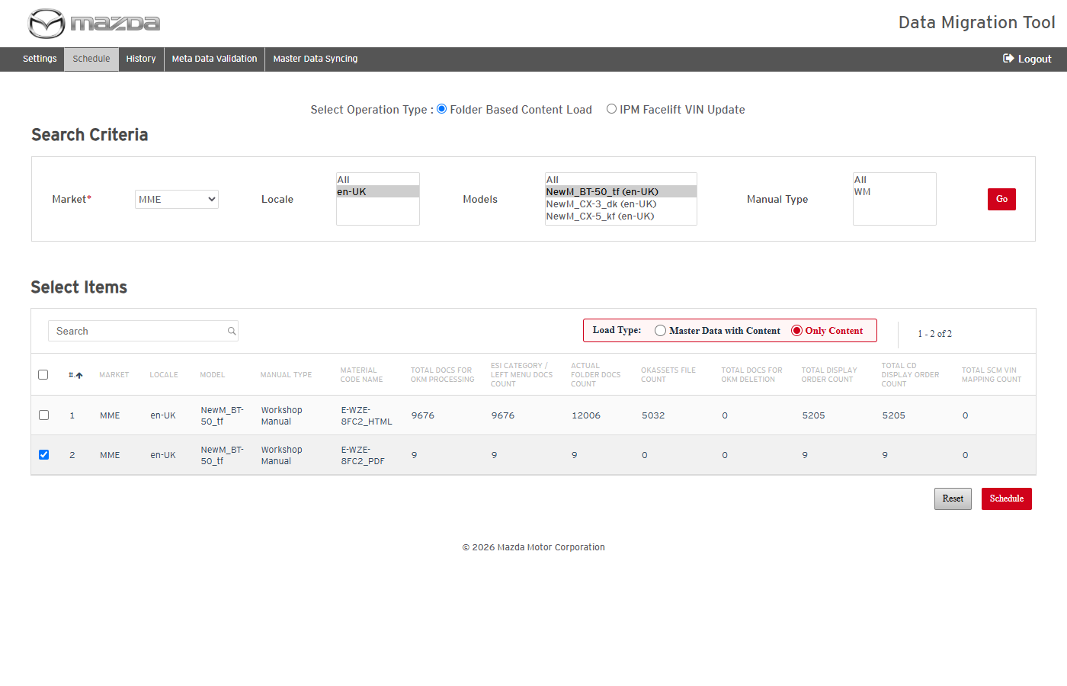
Row selected
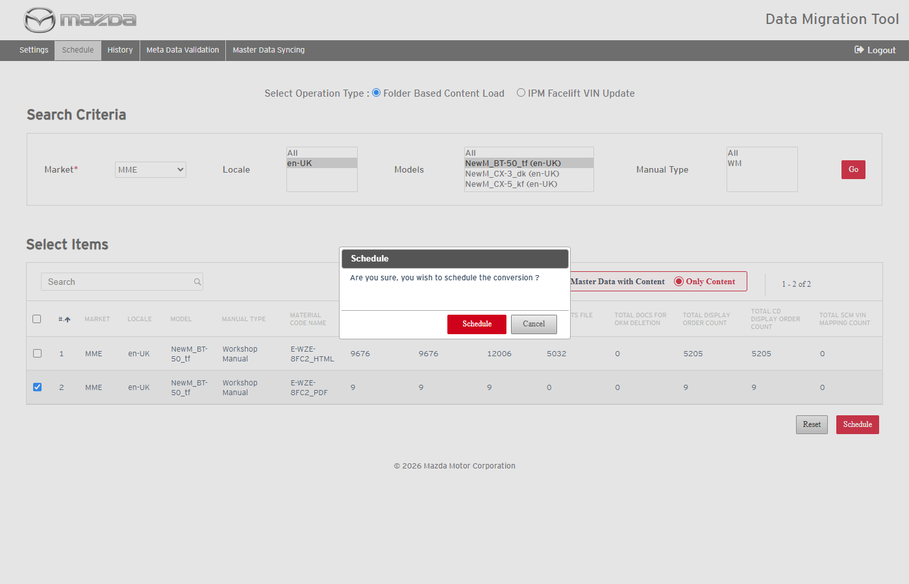
Schedule confirmation
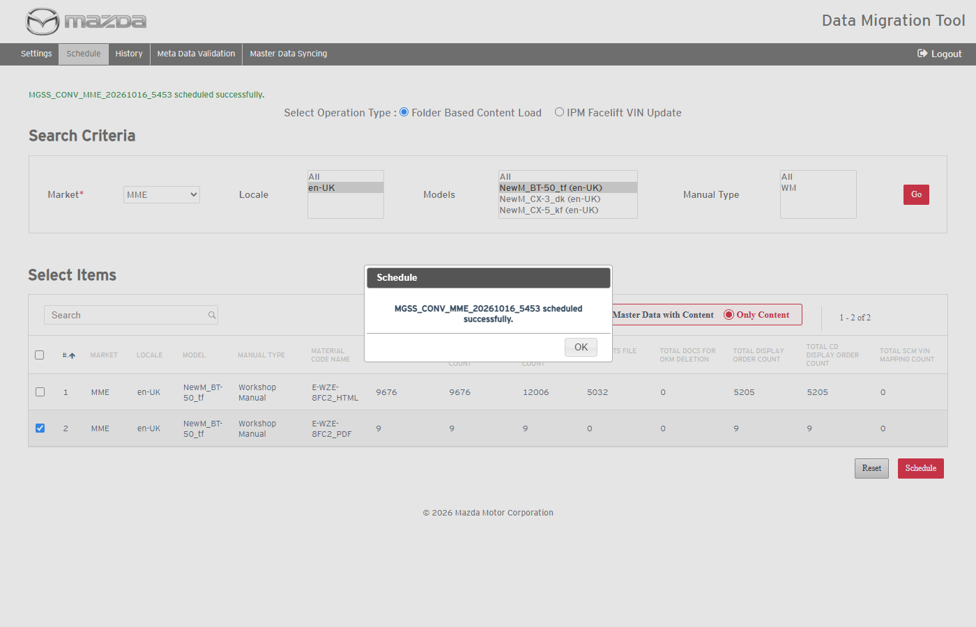
Conversion scheduled
Status: Pass
Remarks:

- User should be able to schedule a conversion with load type Master Data with Content.
Steps:
1. Select a row, choose Master Data with Content and schedule it.
Expected Result: The job first loads the MDM Excel files of the locale and syncs the waiting categories to Kapture, then converts the content (MASTER_DATA_LOAD_REPORT and MASTER_DATA_CATEGORY_REPORT in the reports zip).
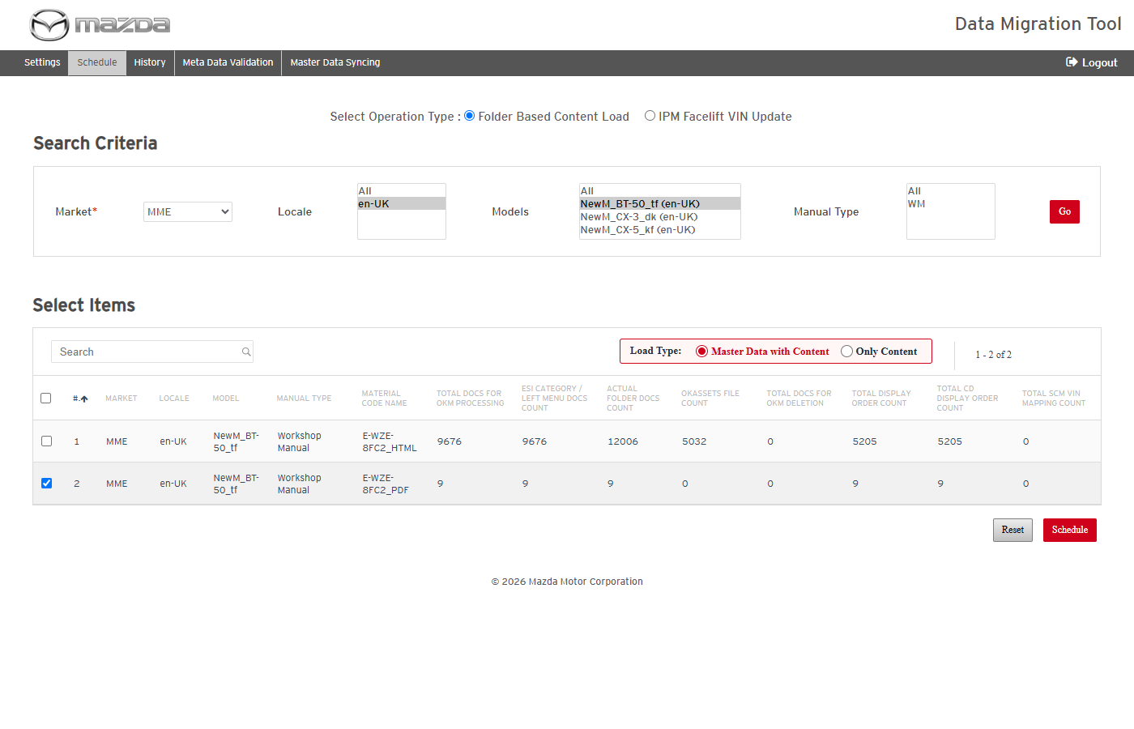
Load type Master Data with Content selected
Status: Pass
Remarks:

- User should be able to reset the conversion selection.
Steps:
1. Click Reset and confirm with Reset.
Expected Result: "Are you sure, you wish to reset, all the selection for conversion will be lost ?" is asked; the selections and listed items are cleared.
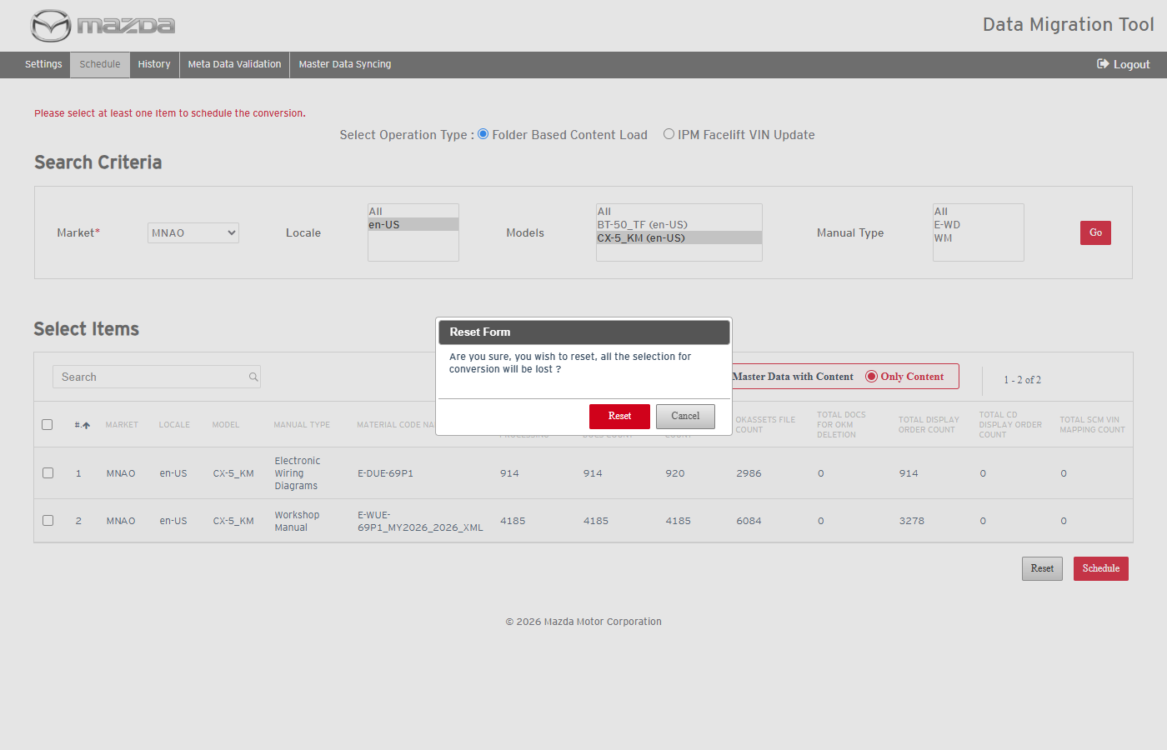
Reset confirmation
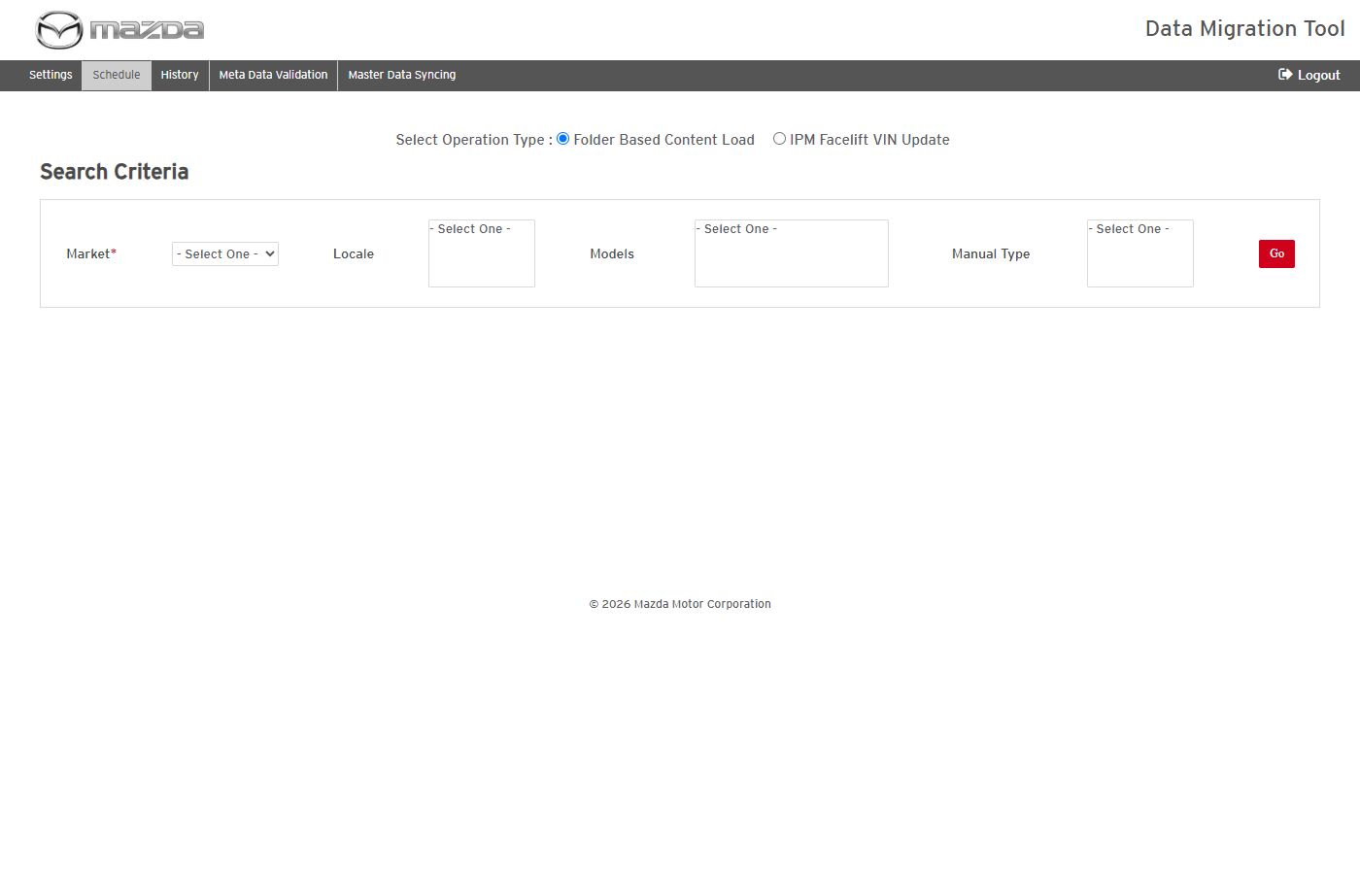
Schedule page after reset
Status: Pass
Remarks:

Conversion and Scheduling Validation Rules
Checks made before a job is scheduled (Schedule screen, Preview publish, IPM Facelift VIN Update and Master Data Syncing). Rules 3 to 8 are checked per selected row on Schedule, in this order.
- Market is mandatory for Go.
Steps:
1. Open Schedule and click Go without selecting a Market.
Expected Result: "Please fill all the fields marked as mandatory (*)." is shown.
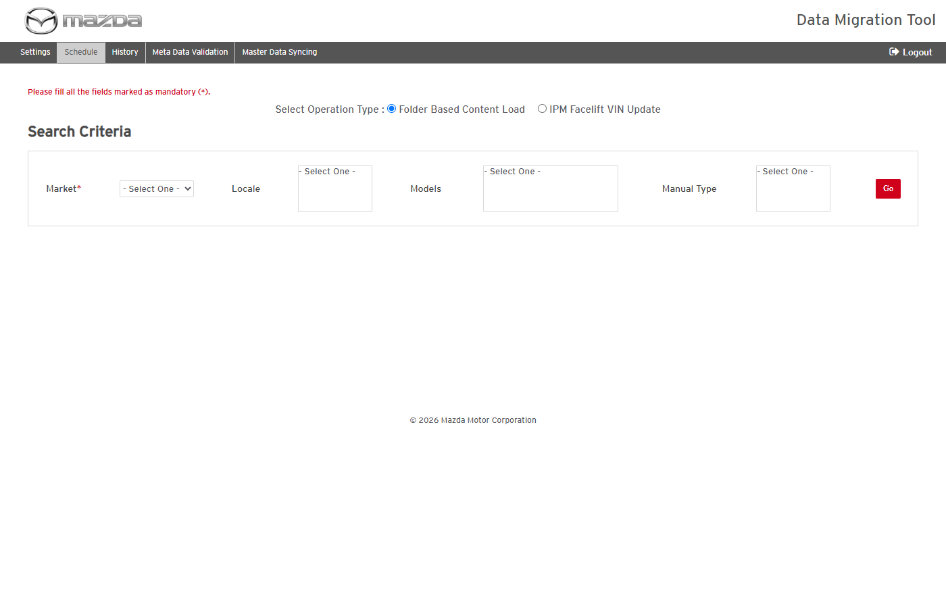
Mandatory Market
Status: Pass
Remarks:

- At least one row must be selected to schedule a conversion.
Steps:
1. List items with Go and click Schedule without selecting a row.
Expected Result: "Please select at least one Item to schedule the conversion." is shown.
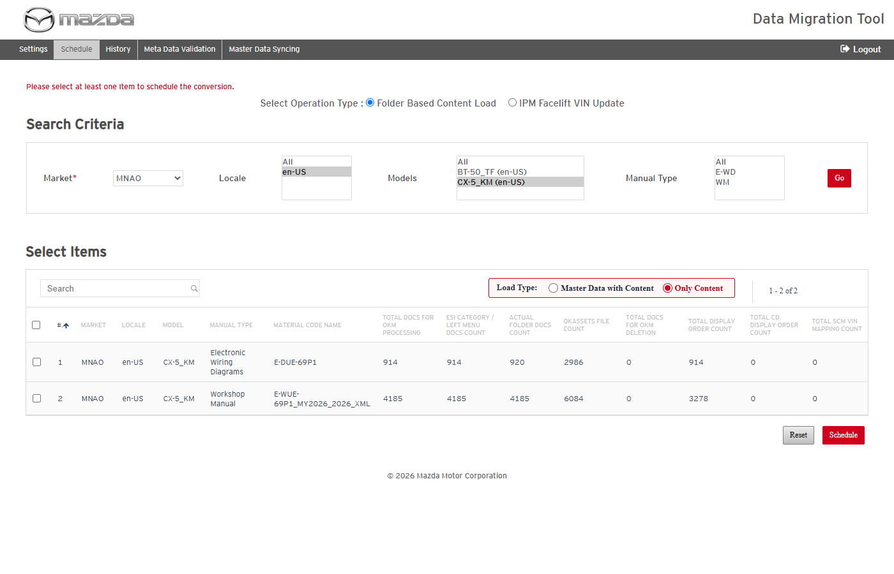
No row selected
Status: Pass
Remarks:

- A row without VIN file and display order file cannot be scheduled.
Pre-condition: Facelift folder without vin.txt and without d01.txt.
Steps:
1. Select the row and click Schedule.
Expected Result: "Row No. <n> cannot be selected for Content Load, as they do not contain any Display Order & VIN Text File."
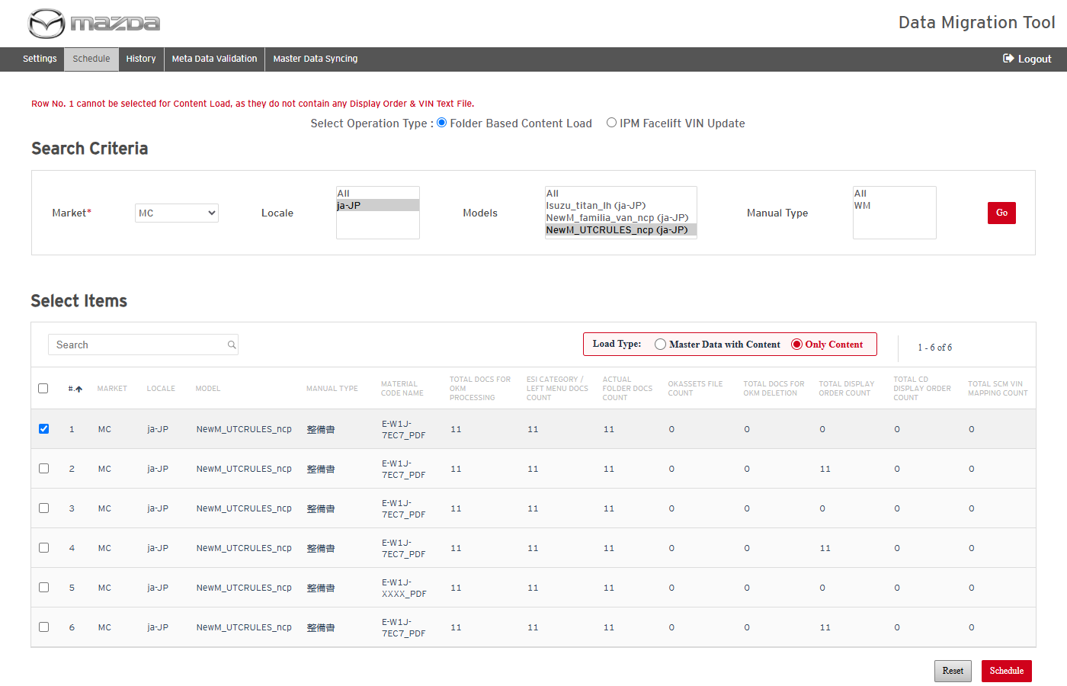
No VIN and no display order file
Status: Pass
Remarks:

- A row with only the display order file cannot be scheduled.
Pre-condition: Facelift folder with d01.txt but without vin.txt.
Steps:
1. Select the row and click Schedule.
Expected Result: "Row No. <n> cannot be selected for Content Load, as they contain only Display Order Text File and No VIN Text File."
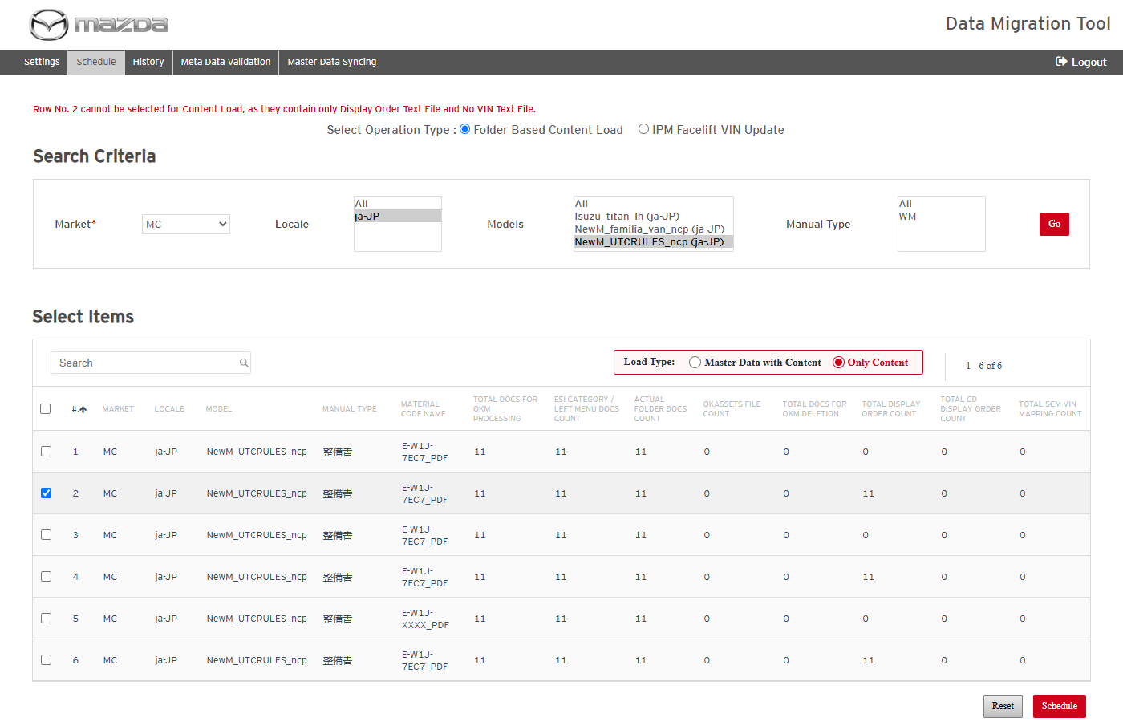
Only display order file
Status: Pass
Remarks:

- A row with only the VIN file cannot be scheduled.
Pre-condition: Facelift folder with vin.txt but without d01.txt.
Steps:
1. Select the row and click Schedule.
Expected Result: "Row No. <n> cannot be selected for Content Load, as they contain only VIN Text File and No Display Order Text File."
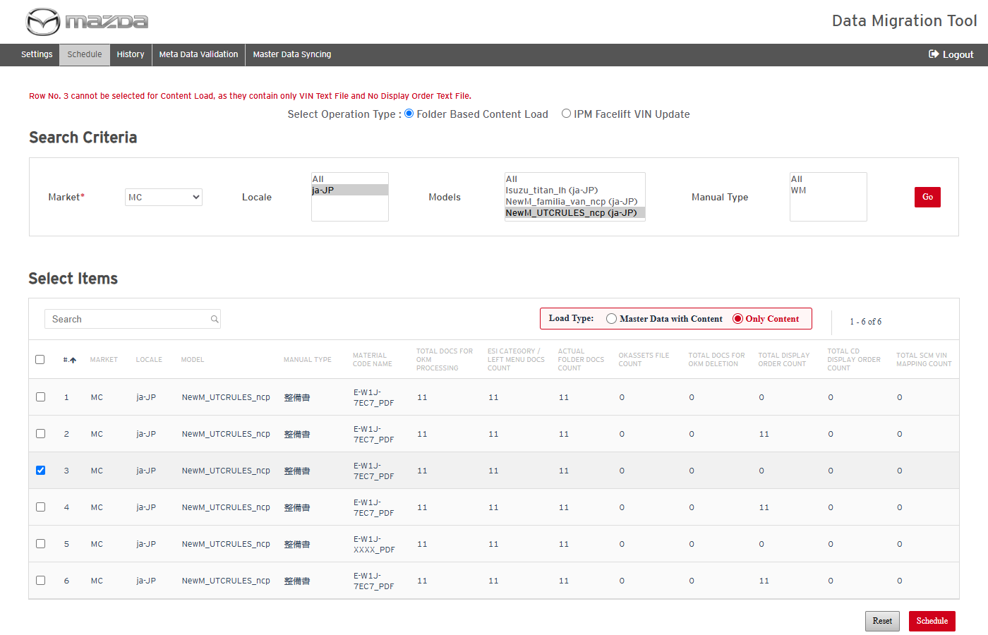
Only VIN file
Status: Pass
Remarks:

- The display order file named in vin.txt must exist.
Pre-condition: vin.txt names d05.txt, which is not in the facelift folder.
Steps:
1. Select the row and click Schedule.
Expected Result: "Row No. <n> cannot be selected for Content Load, as the required Text file for Display Order provided in VIN.Txt is missing."
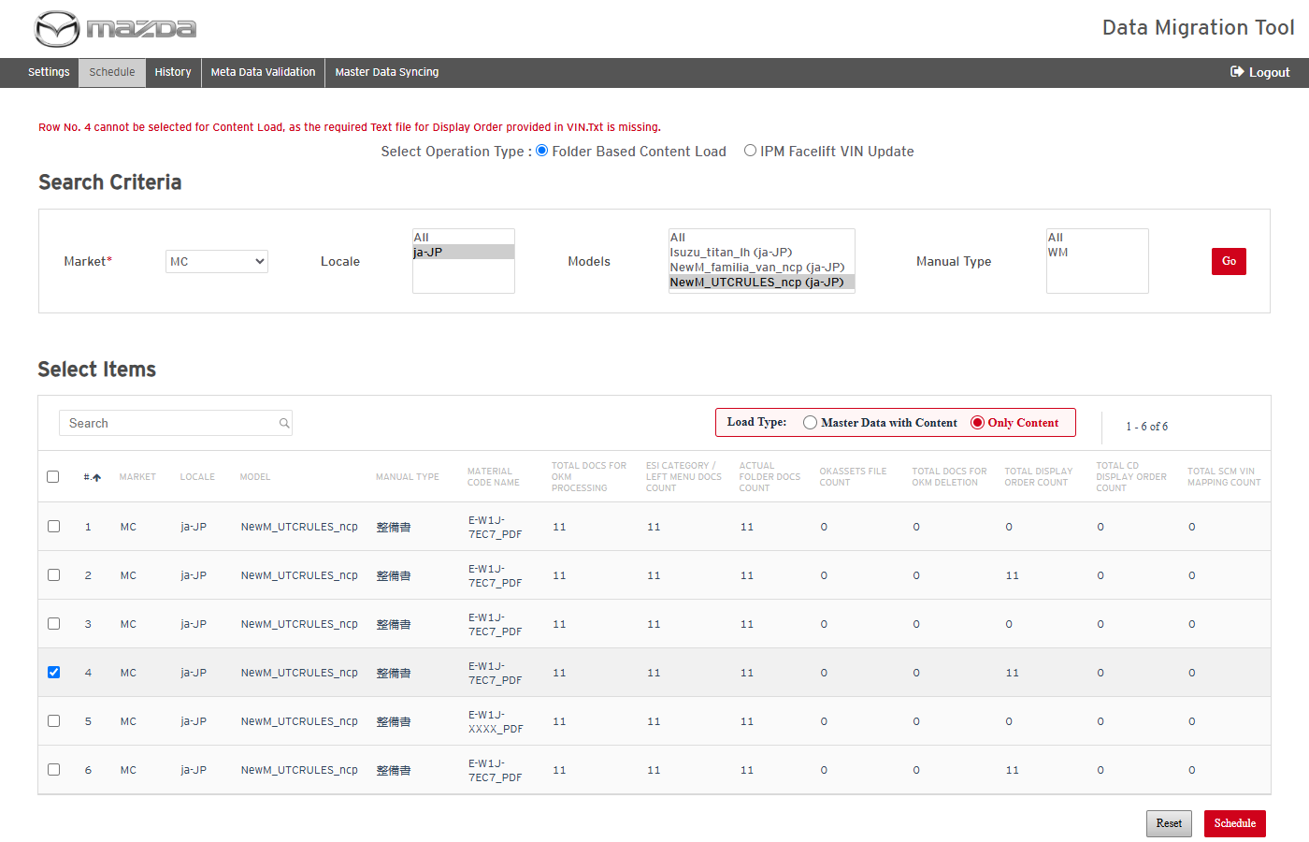
Display order file named in vin.txt missing
Status: Pass
Remarks:

- The material folders named in vin.txt must exist under the facelift folder.
Pre-condition: vin.txt names material folders that do not exist under the facelift folder.
Steps:
1. Select the row and click Schedule.
Expected Result: "Row No. <n> cannot be selected for Content Load, as all the Material Folder identified from the VIN Text file(s) does not exist under Parent FaceLift folder."
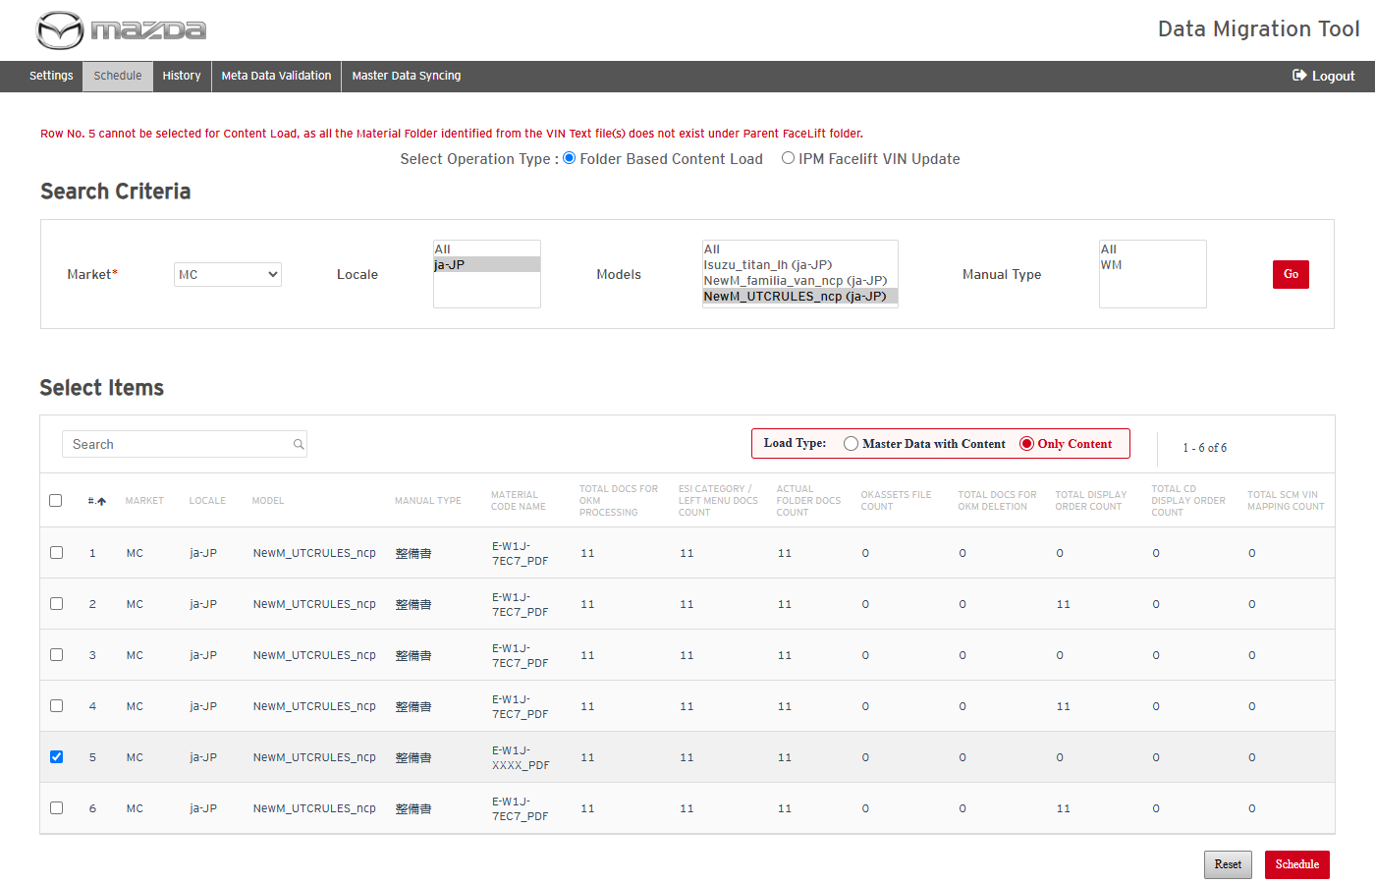
Material folders missing
Status: Pass
Remarks:

- VIN lines must carry proper VINs.
Pre-condition: vin.txt line with missing VIN fields (e.g. WM||FL0006||E-W1J-7EC7_PDF||NCP||d01.txt;).
Steps:
1. Select the row and click Schedule.
Expected Result: "Row No. <n> cannot be selected for Content Load, VIN File(s) - vin.txt does not have proper VINs defined."
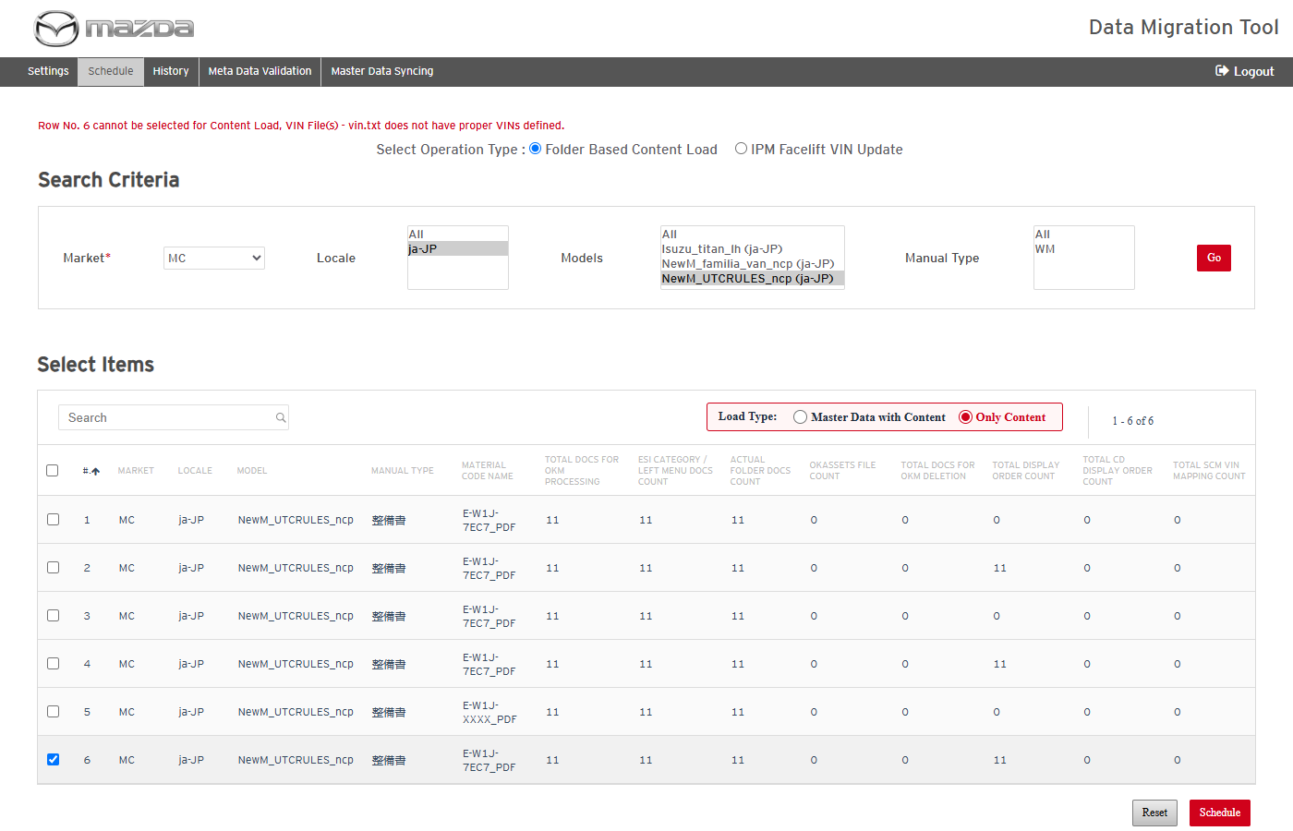
VIN file without proper VINs
Status: Pass
Remarks:

- Only Content is refused while categories of the locale are waiting for sync.
Pre-condition: MDM rows of the selected locale are waiting for sync.
Steps:
1. Schedule the row with Load Type Only Content.
Expected Result: "<n> Categories are still remaining for Syncing in Kapture for <market> Market (locale <locale>). Please select "Master Data with Content", which loads the master data before the content."
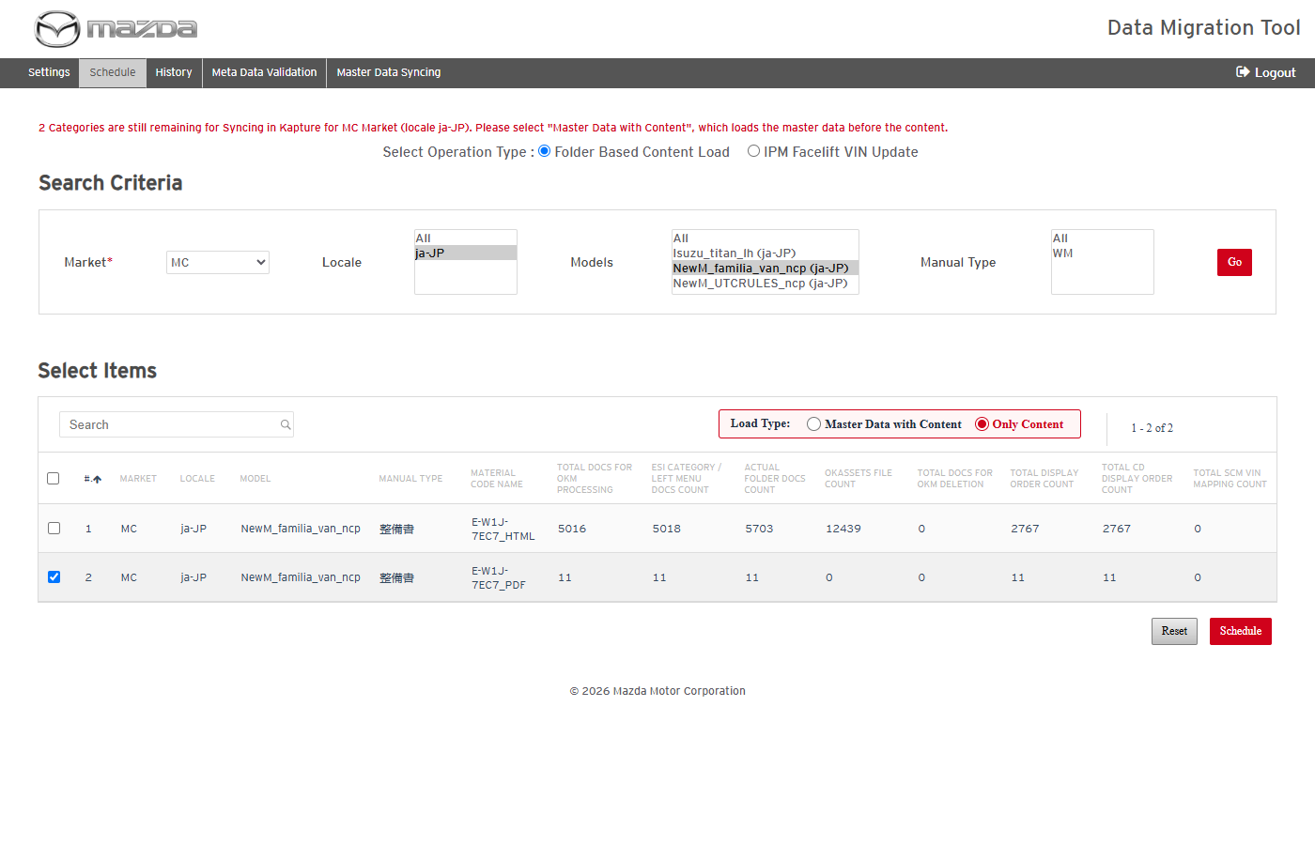
Master data waiting for sync
Status: Pass
Remarks:

- A row can be in only one Pending / Processing conversion or publish job.
Steps:
1. While a conversion of a row is Processing, schedule the same row again.
Expected Result: "Cannot proceed further. Row No.<n> is already Processing under - <job>."
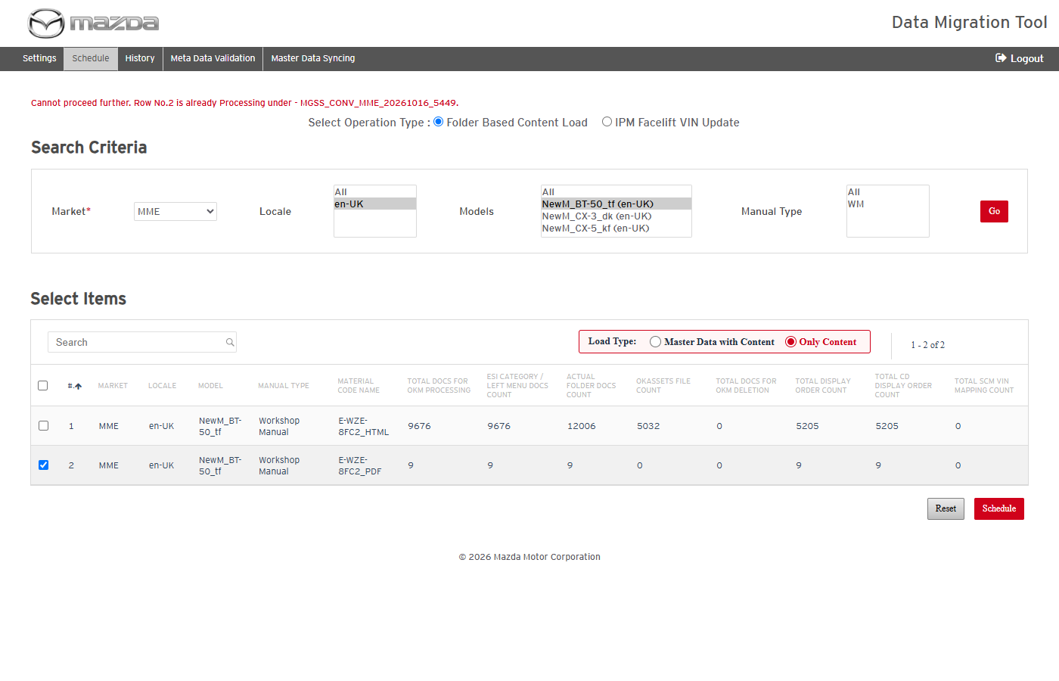
Row already processing
Status: Pass
Remarks:

- A conversion / publish job is refused while a master job is Pending / Processing.
Steps:
1. While a Master Data Syncing / IPM Facelift VIN Update / Document Identification job is Pending or Processing, schedule a conversion.
Expected Result: "The Conversion / Publish job cannot be scheduled now - an IPM Facelift VIN Update / Document Identification / Master Data Syncing job is Pending / Processing: <jobs>. Please try after sometime."
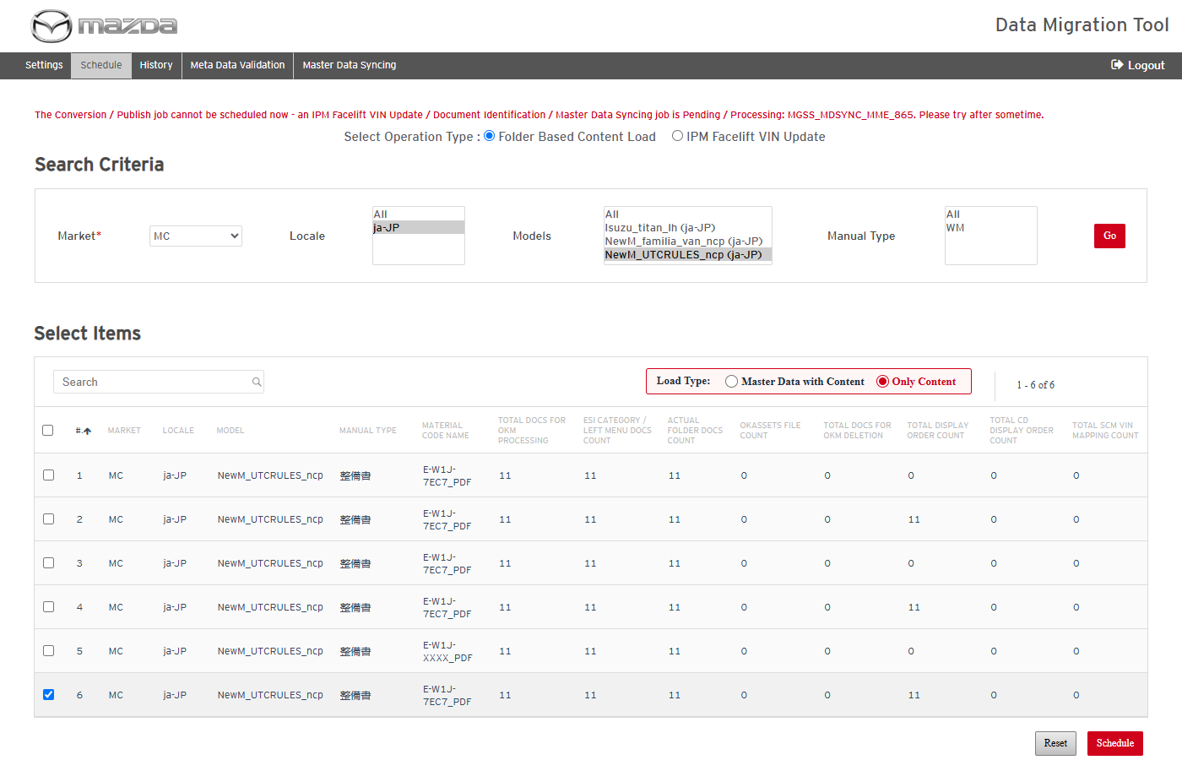
Conversion refused while a master job runs
Status: Pass
Remarks:

- A master job is refused while a conversion / publish job is Pending / Processing.
Steps:
1. While a conversion is Processing, schedule Master Data Syncing, or click Submit (Identify) on IPM Facelift VIN Update.
Expected Result: "The job cannot be scheduled now - a Conversion / Publish job is Pending / Processing: <jobs>. IPM Facelift VIN Update, Document Identification and Master Data Syncing can be scheduled when those jobs finish."
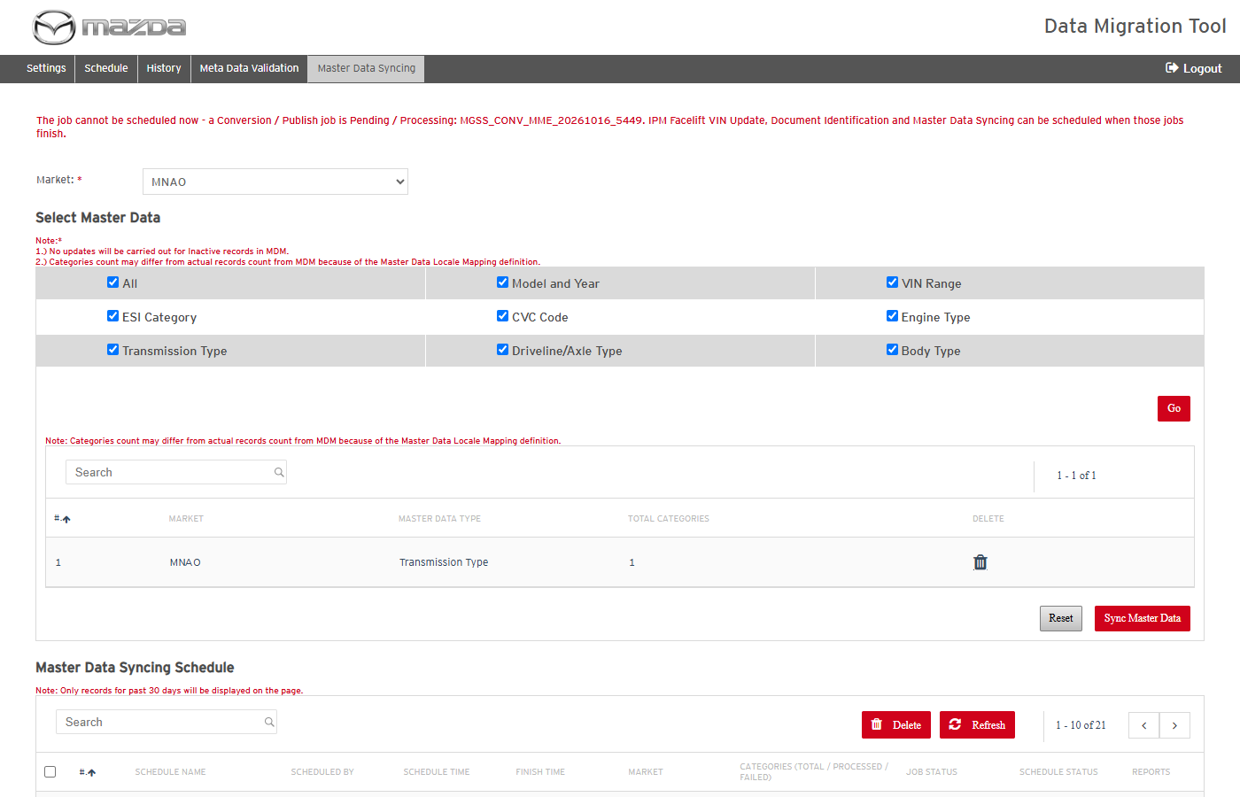
Master Data Syncing refused
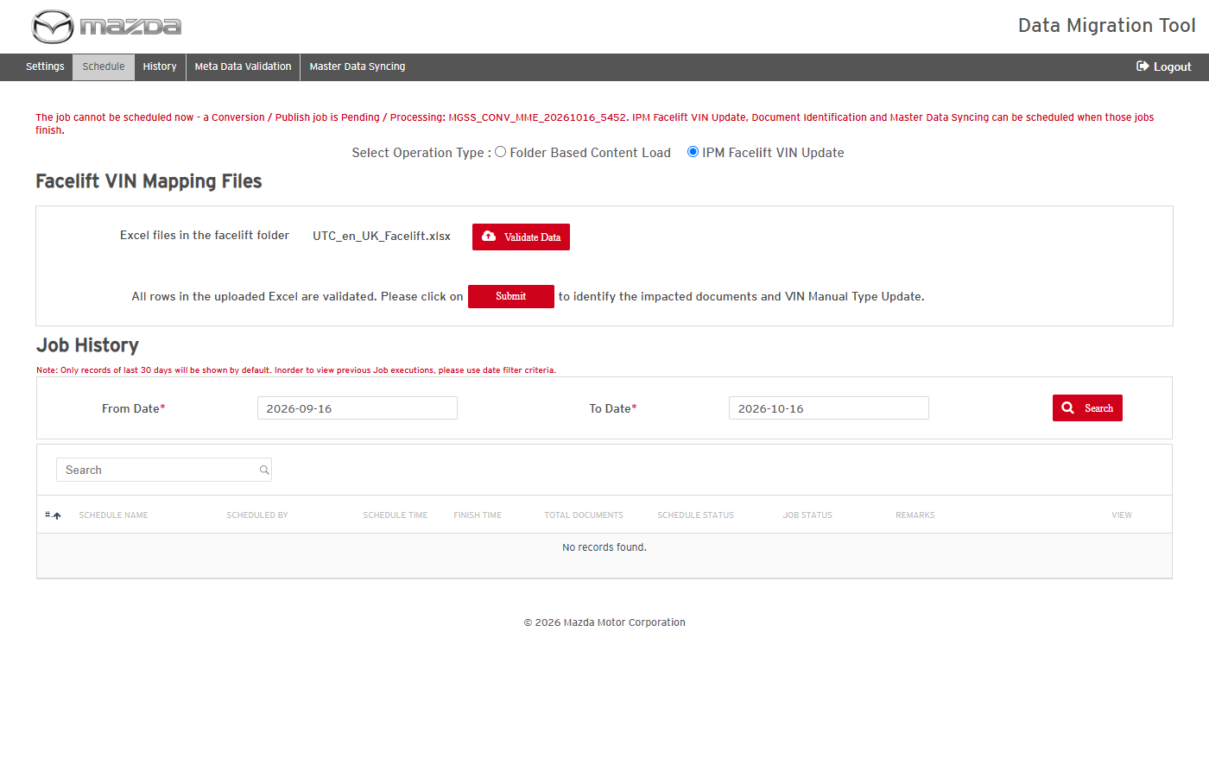
Facelift Identify refused
Status: Pass
Remarks:

- At most 5 jobs can be Pending / Processing at the same time.
Steps:
1. With 5 jobs (any type, Meta Data Validation not counted) Pending / Processing, schedule another job.
Expected Result: "The job cannot be scheduled now - the limit of 5 jobs Pending / Processing at the same time is reached: <jobs>. Please try after sometime."
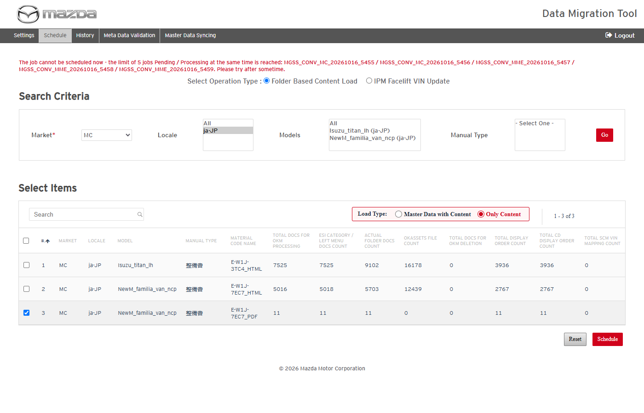
Sixth job refused - 5 jobs Pending / Processing
Status: Pass
Remarks:

- Publish is refused when nothing is left to publish (or while the conversion is still running).
Steps:
1. Open the Preview of a job whose documents are all published.
Expected Result: "There is nothing to preview for this job: it has no unpublished document." and Publish Content is disabled.
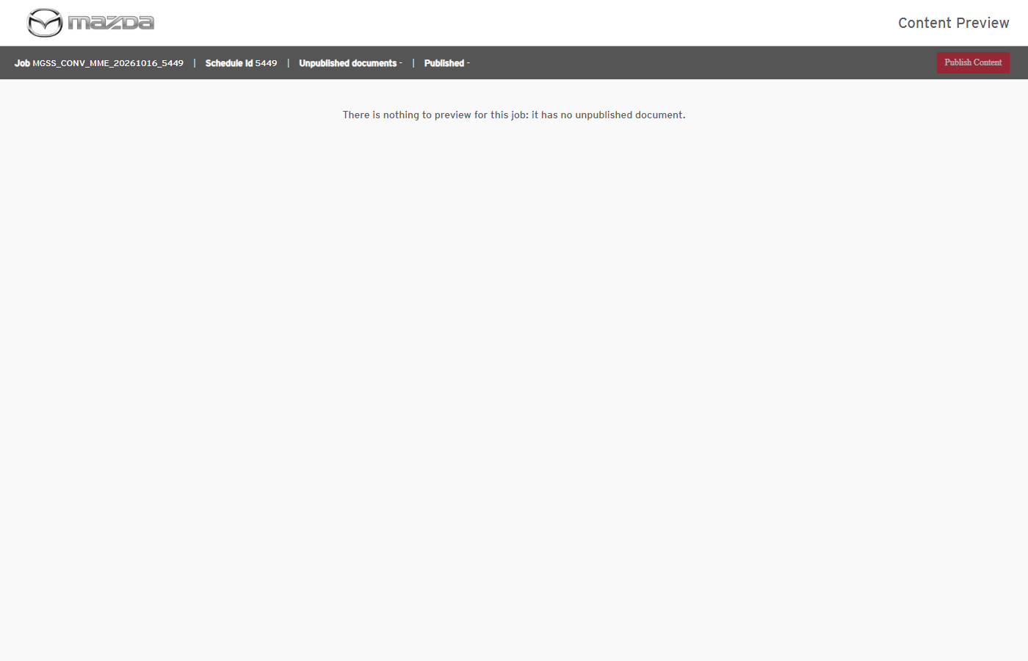
Nothing left to publish
Status: Pass
Remarks:

History and Reports
- User should be able to follow jobs and view item details on History.
Steps:
1. Open History, click Refresh while the job runs, then open the job's View (item details).
Expected Result: Jobs are listed with Content Status / Job Status and the Documents, OKAssets, Innerlinks, Delete, Display Order, CD Display Order and SCM VIN Mapping counts (Total / Processed / Failed).
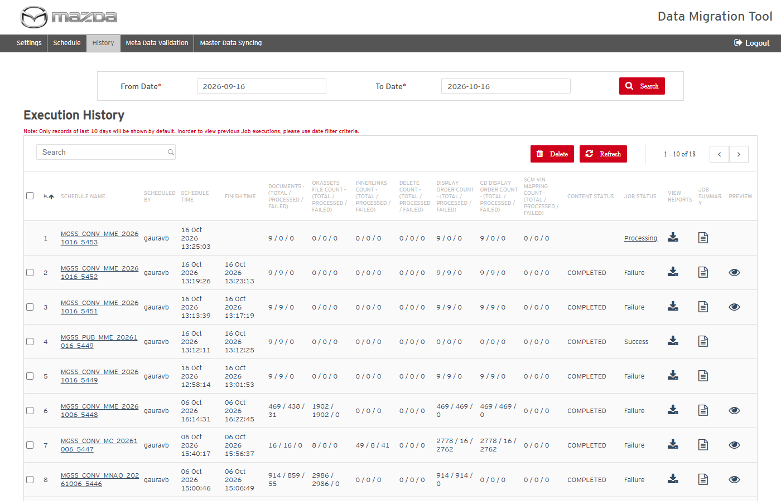
Job Processing
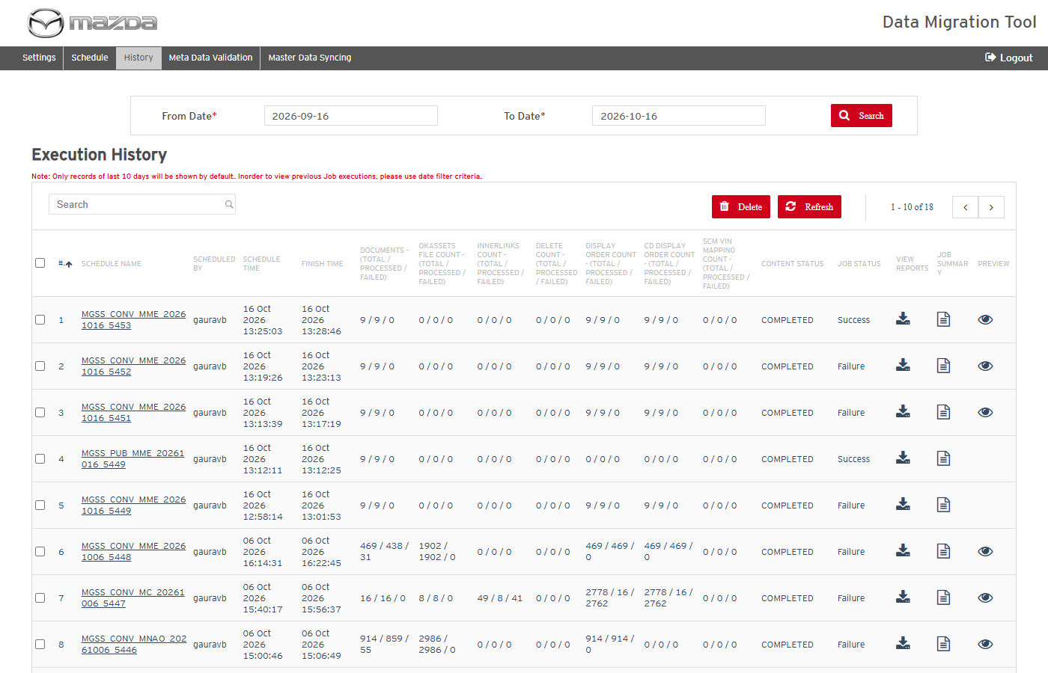
Job COMPLETED - Success
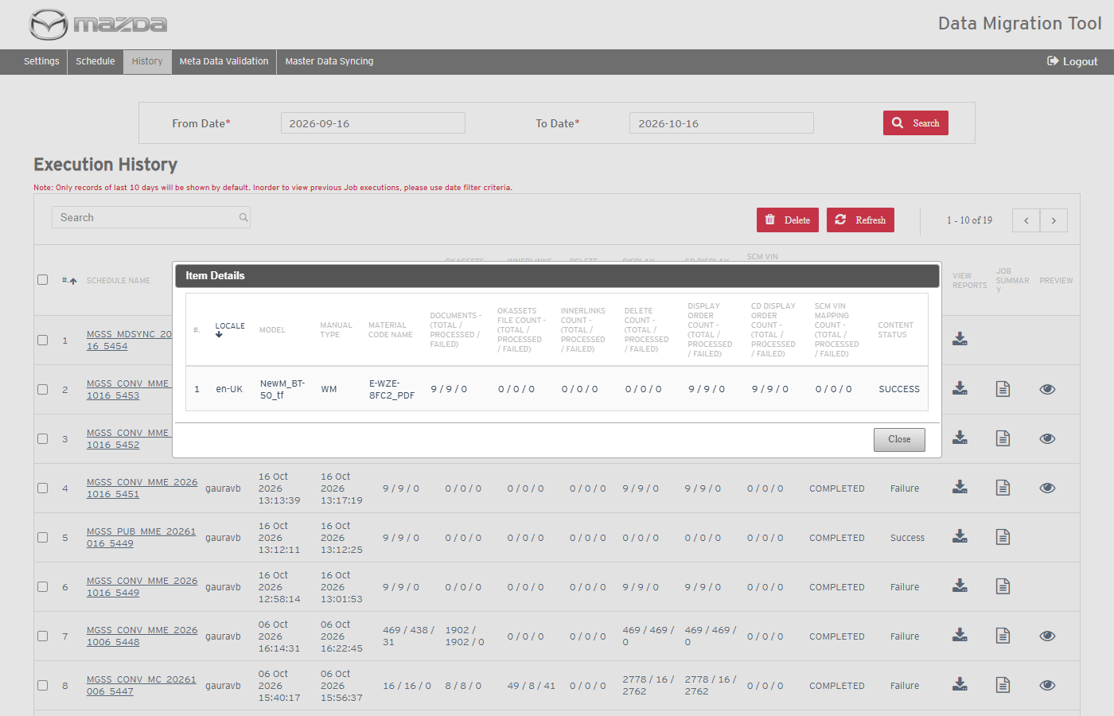
Item details
Status: Pass
Remarks:

- User should be able to view the job summary and download the reports.
Steps:
1. Click Job Summary of a completed job.
2. Click Reports and open the downloaded zip.
Expected Result: The summary lists each report with its status and transaction counts; the zip contains TRANSACTION_REPORT, DISPLAY_ORDER, CD_PROCESSING_DATA, VIEW_CONTENT_REPORT (and failure / missing categories reports when there are errors).
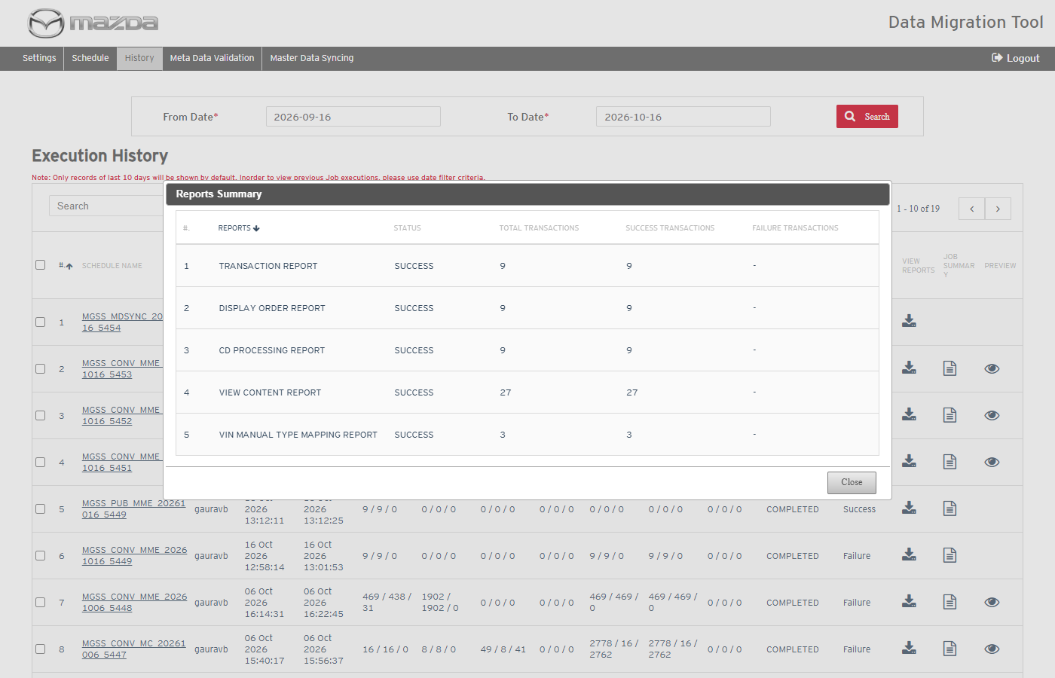
Reports summary
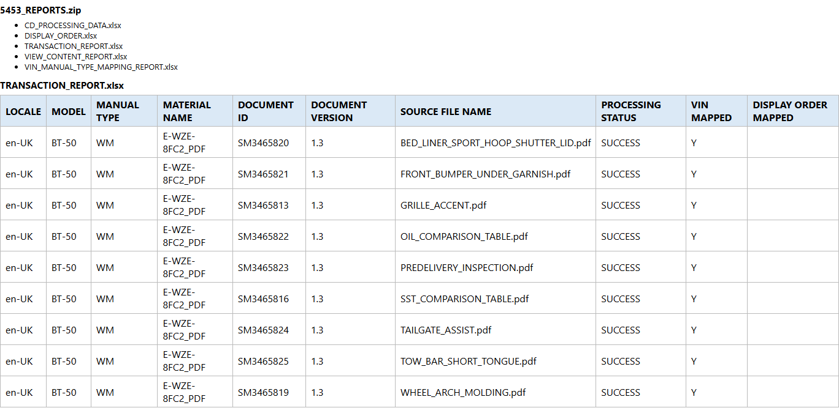
Reports zip - TRANSACTION_REPORT
Status: Pass
Remarks:

- User should be able to abort a running conversion.
Steps:
1. Click Abort Conversion of a Processing job and confirm.
Expected Result: "Are you sure, you wish to abort the conversion ?" is asked; on confirmation the job status becomes Aborted.
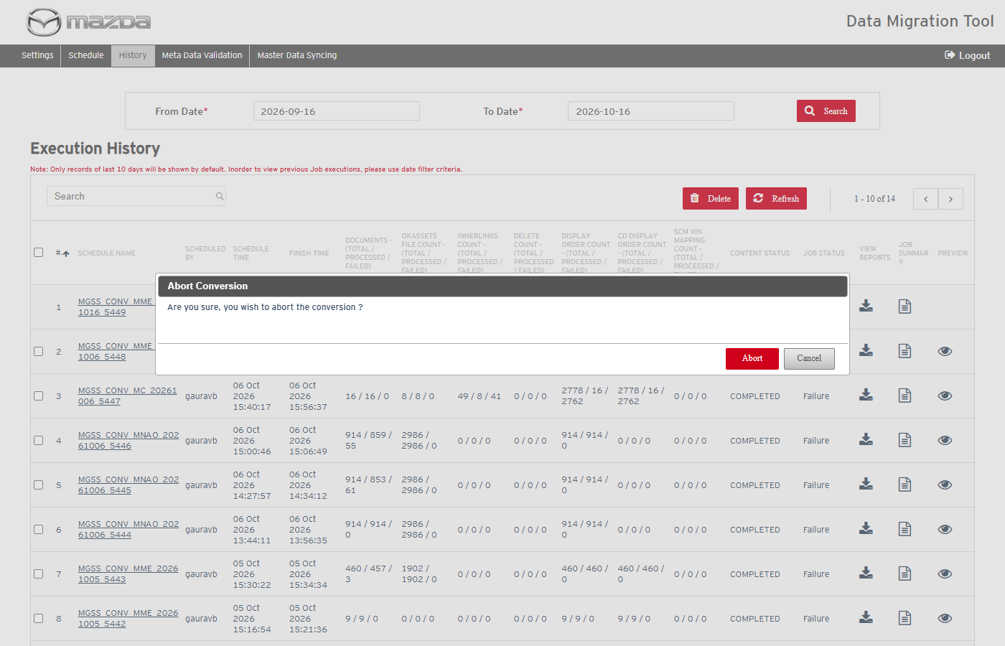
Abort confirmation
Status: Pass
Remarks:

- User should be able to delete schedules from History.
Steps:
1. Click Delete without a selection.
2. Select schedule(s), click Delete and confirm with Yes.
Expected Result:
- Without a selection: "Please select atleast 1 row to delete."
- "Schedule(s) deleted successfully." and the schedules are removed.
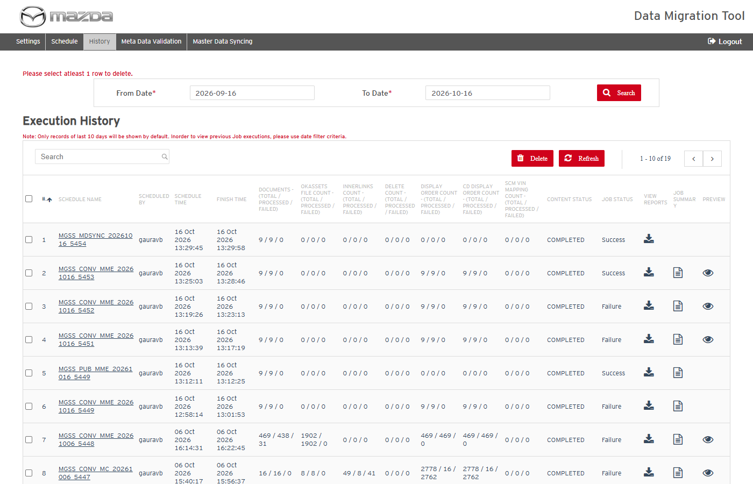
No row selected
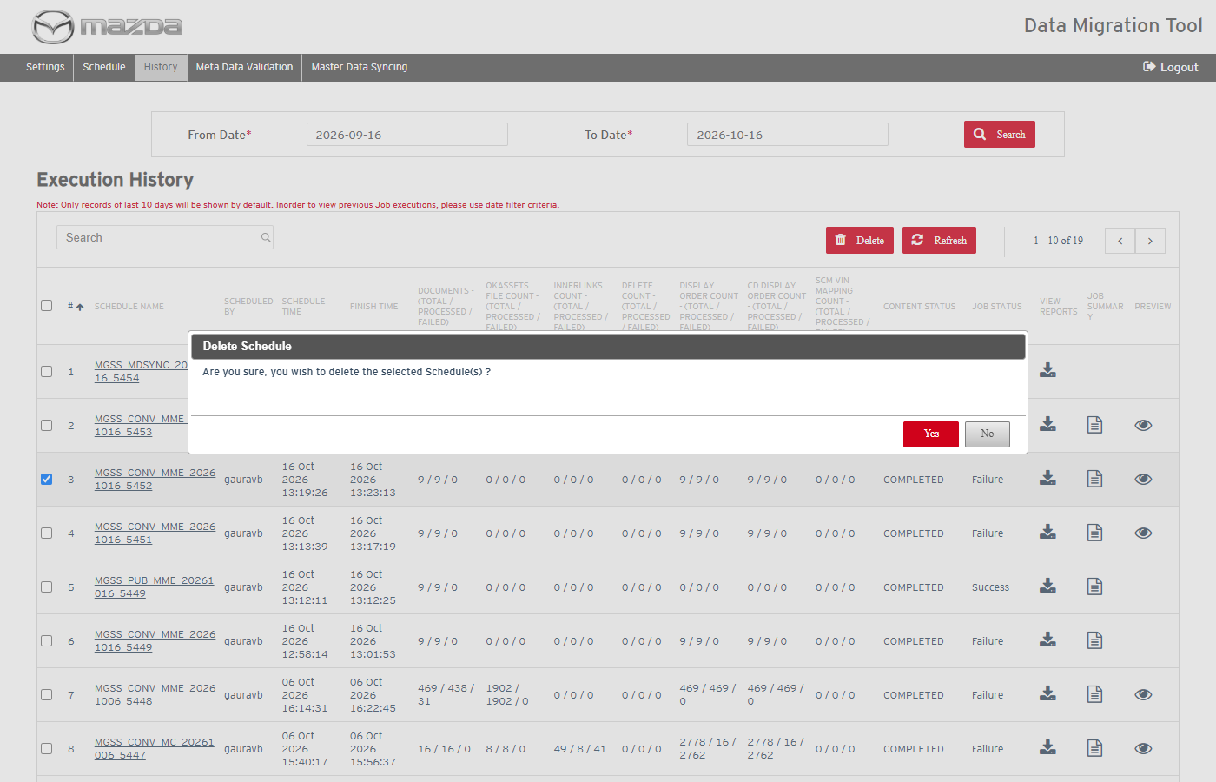
Delete confirmation
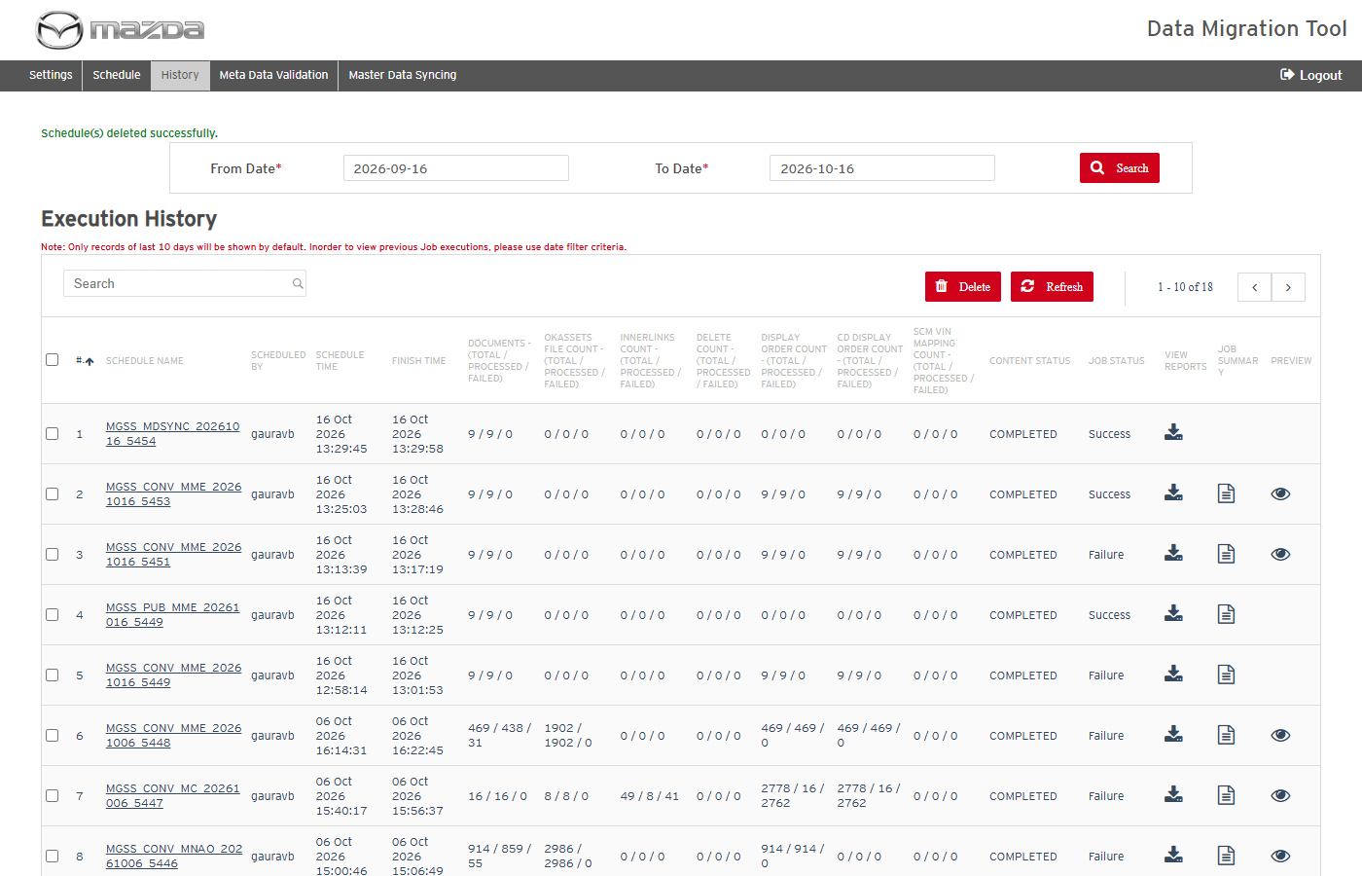
Delete result
Status: Pass
Remarks:

Preview and Publish
- User should be able to preview the documents of a conversion job.
Steps:
1. On History click the Preview icon of a completed conversion; open a document from the tree.
Expected Result: The tree is shown with Carline / WMI / VDS / VIS Range filters; the document opens with its content, Status (Draft / Published) and version.
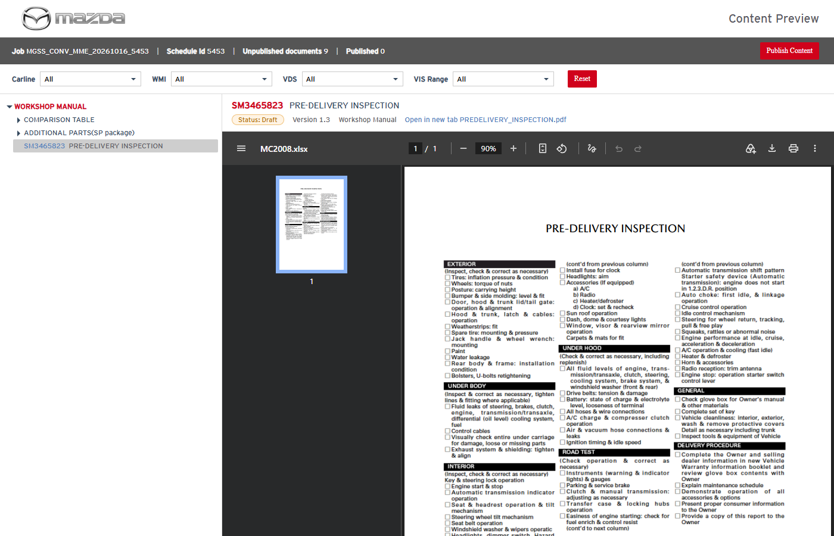
Preview with a document open
Status: Pass
Remarks:

- User should be able to publish the documents of a conversion job from Preview.
Steps:
1. Click Publish Content and confirm with Publish; follow the publish job on History.
Expected Result:
- "Publish job MGSS_PUB_<market>_<date>_<id> has been scheduled. Follow it on the History page."
- The publish job ends COMPLETED / Success and the documents are Published in Kapture.
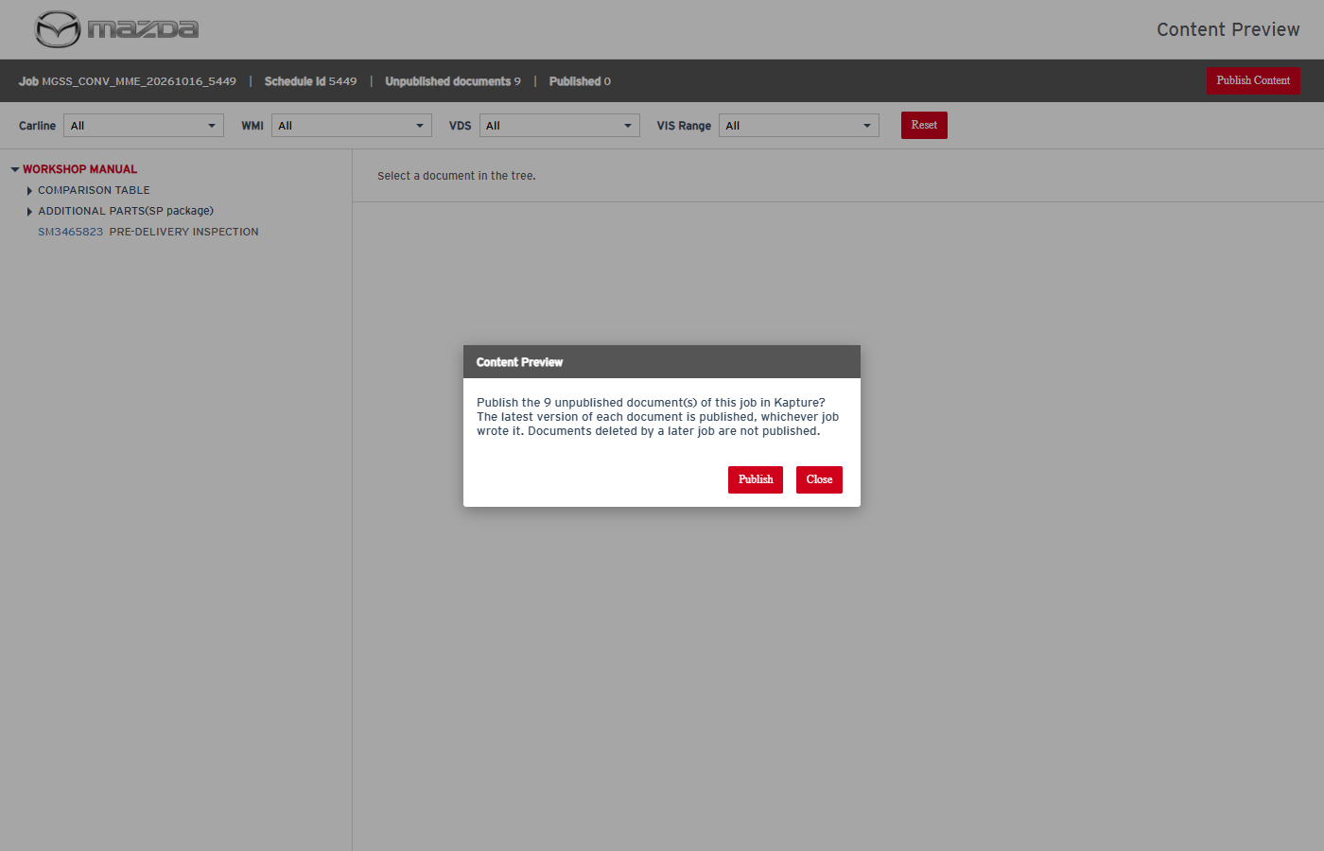
Publish confirmation
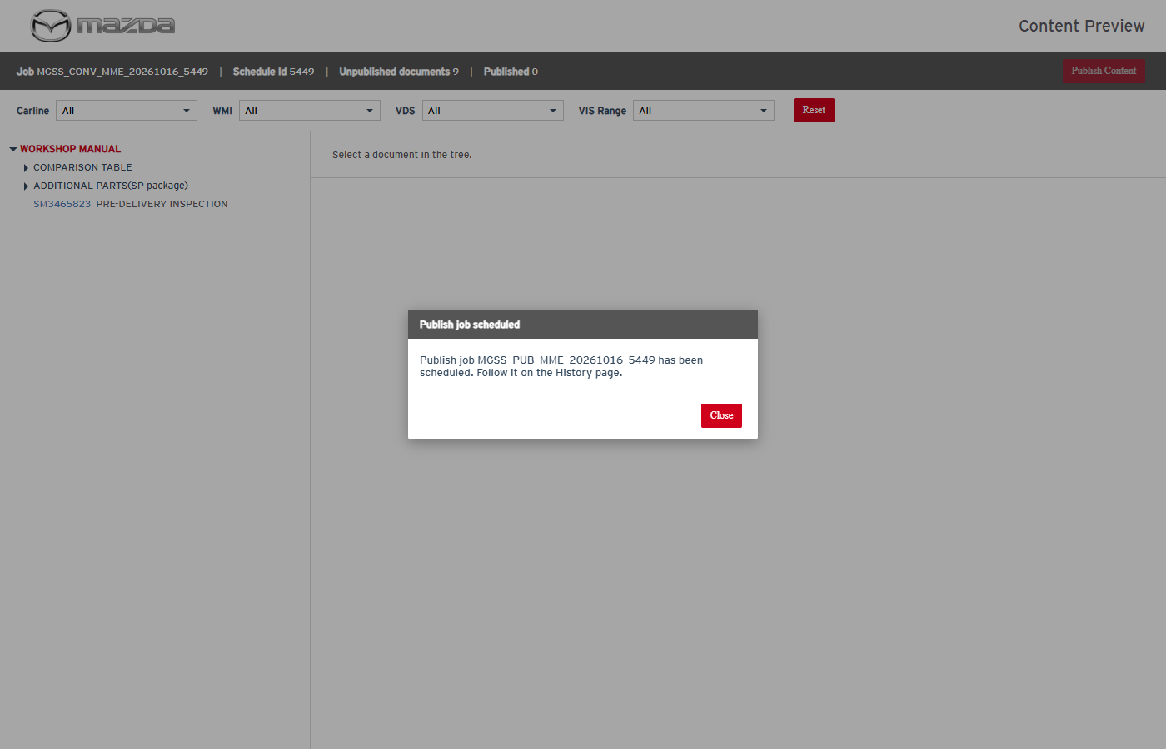
Publish job scheduled
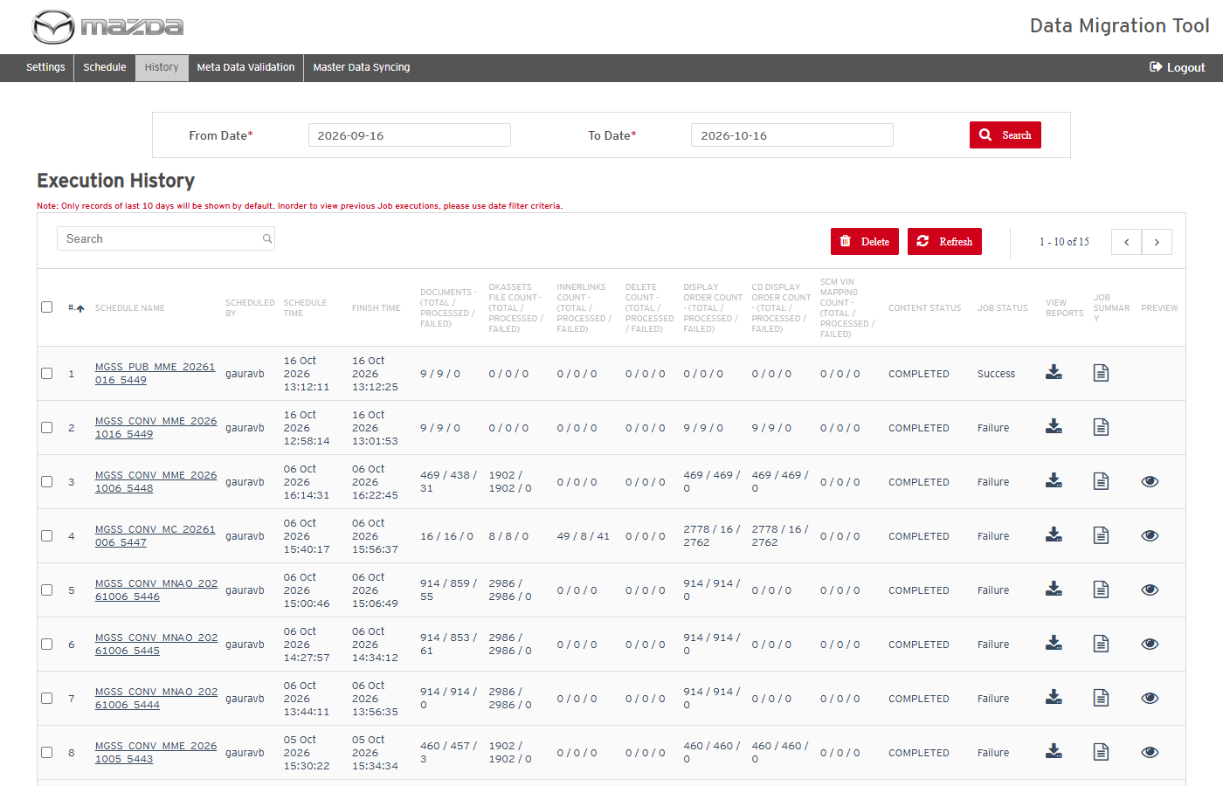
Publish job COMPLETED - Success
Status: Pass
Remarks:

IPM Facelift VIN Update
- User should be able to validate the facelift Excel files.
Pre-condition: Facelift Excel (11 columns: LOCALE, OLD CARLINE CODE ... NEW VIS END RANGE) in Facelift_Content.
Steps:
1. Open Schedule, Operation Type IPM Facelift VIN Update; click Validate Data.
Expected Result: "<n> VIN rows from <n> Excel file(s) validated successfully." and the Submit button is shown.
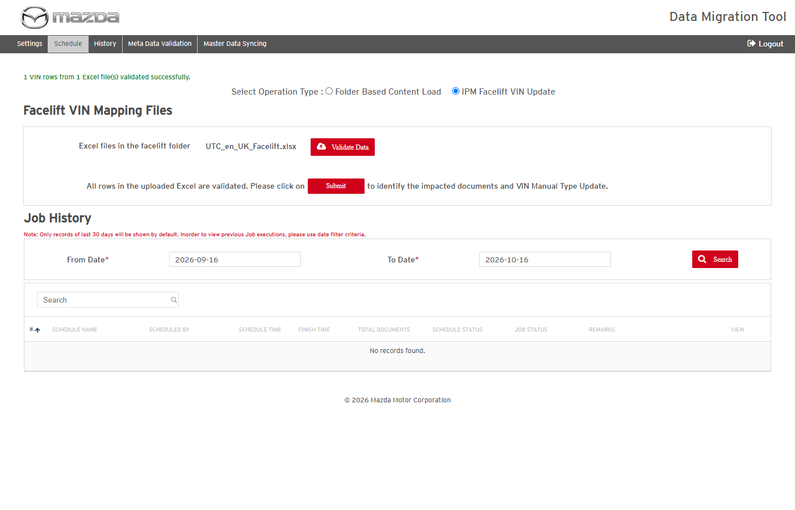
Facelift files validated
Status: Pass
Remarks:

- System should report validation errors in the facelift Excel.
Steps:
1. Use an Excel whose old / new VIN is not in MDM or Kapture and click Validate Data.
Expected Result: Each invalid row is reported (e.g. "Failed to locate ... Old VIN does not exists in MDM for Row No.2 (<file>)"); nothing can be submitted.
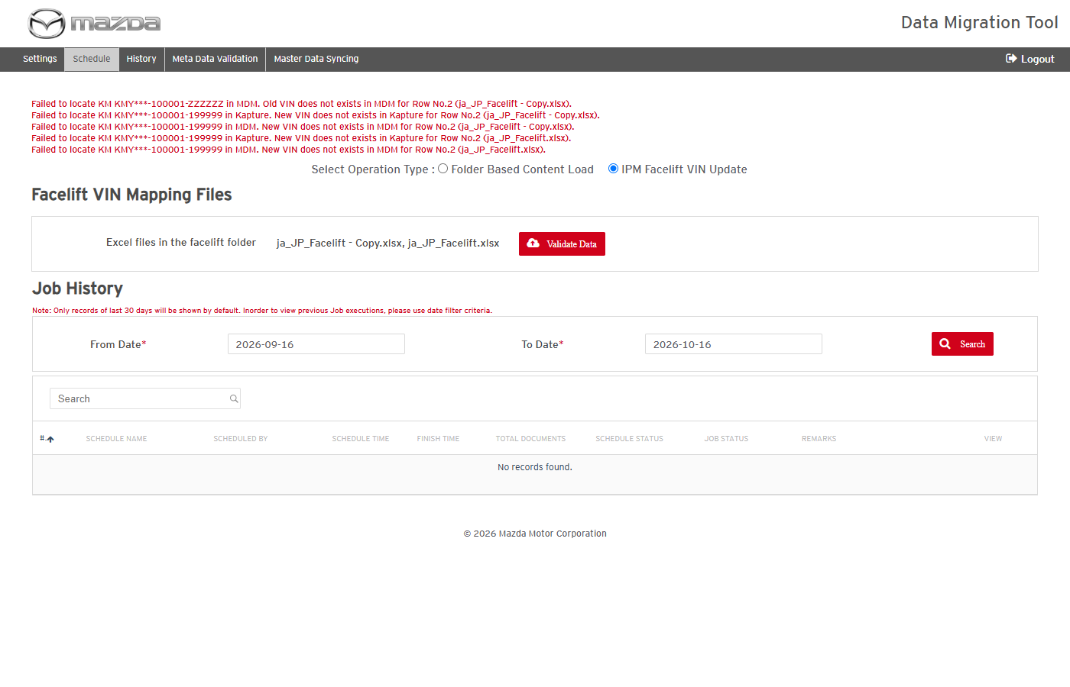
Validation errors
Status: Pass
Remarks:

- User should be able to identify the impacted documents.
Steps:
1. After a successful validation click Submit; refresh until the identification job is finished.
Expected Result: "MGSS_DI_SYNC<date>_<id> scheduled successfully."; the job ends Completed / Success with the total impacted documents.
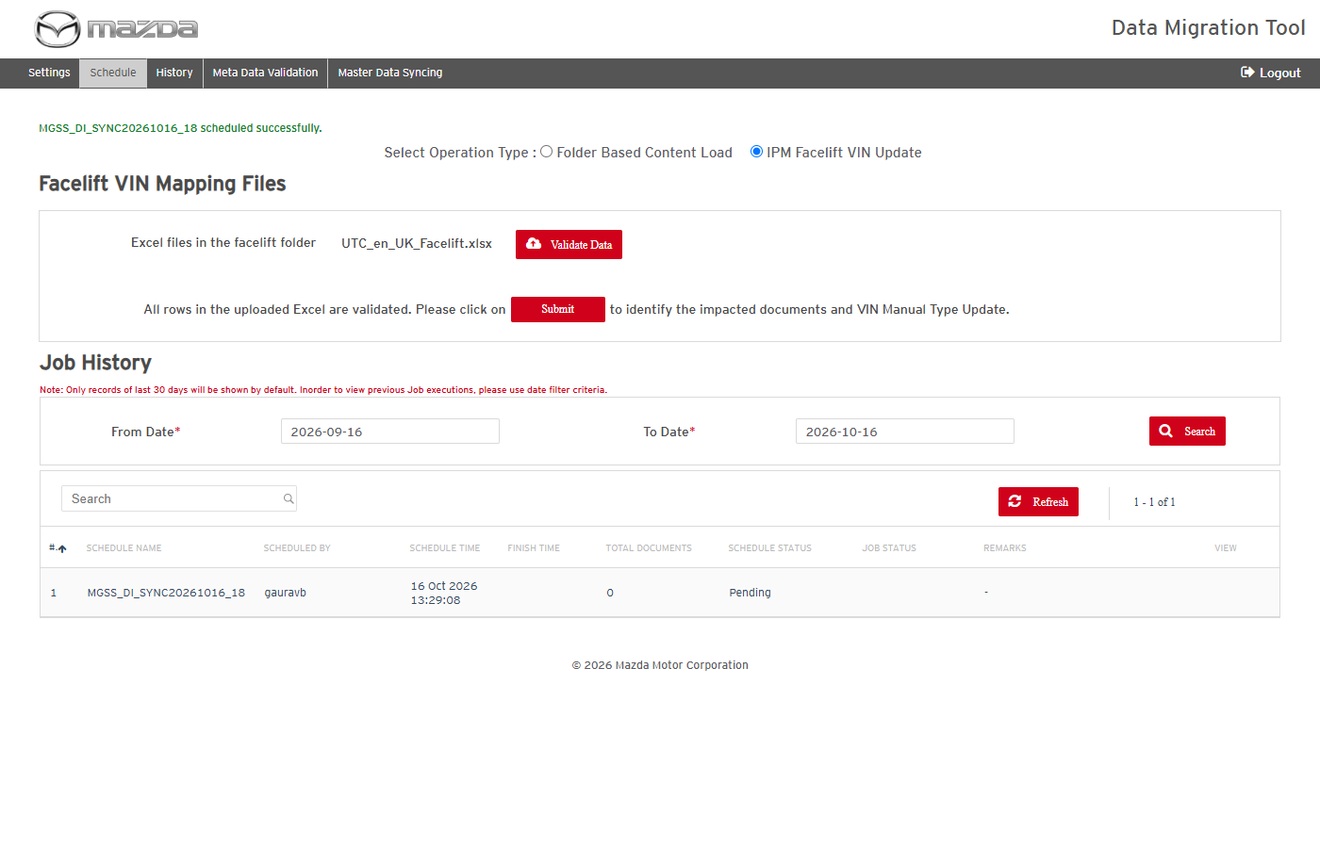
Identification scheduled
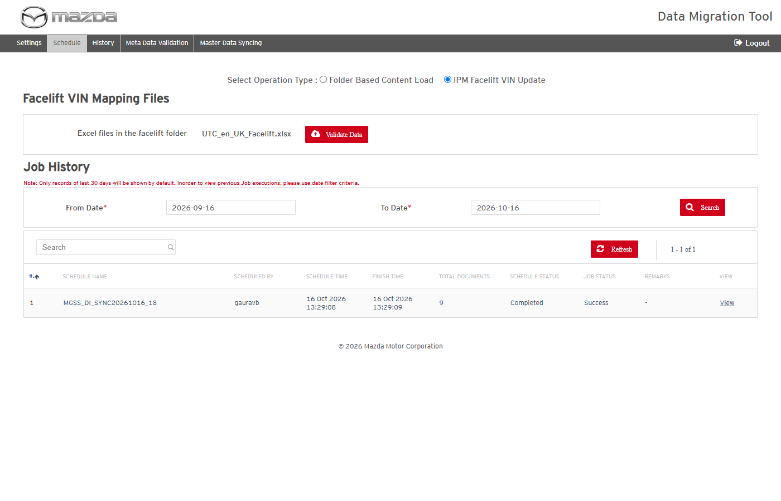
Identification completed
Status: Pass
Remarks:

- User should be able to schedule the IPM Facelift VIN Update for the identified items.
Steps:
1. Click View of the identification job, select the items and Load Type Only Facelift (or Master Data with Facelift).
2. Click Schedule, confirm with Schedule and follow the job on History.
Expected Result:
- "MGSS_MDSYNC_<date>_<id> scheduled successfully."; the job ends COMPLETED / Success.
- Old VIN categories are replaced by the new ones; published documents are published again; old VIN ranges become inactive in MDM (a range that is also a new range is kept).
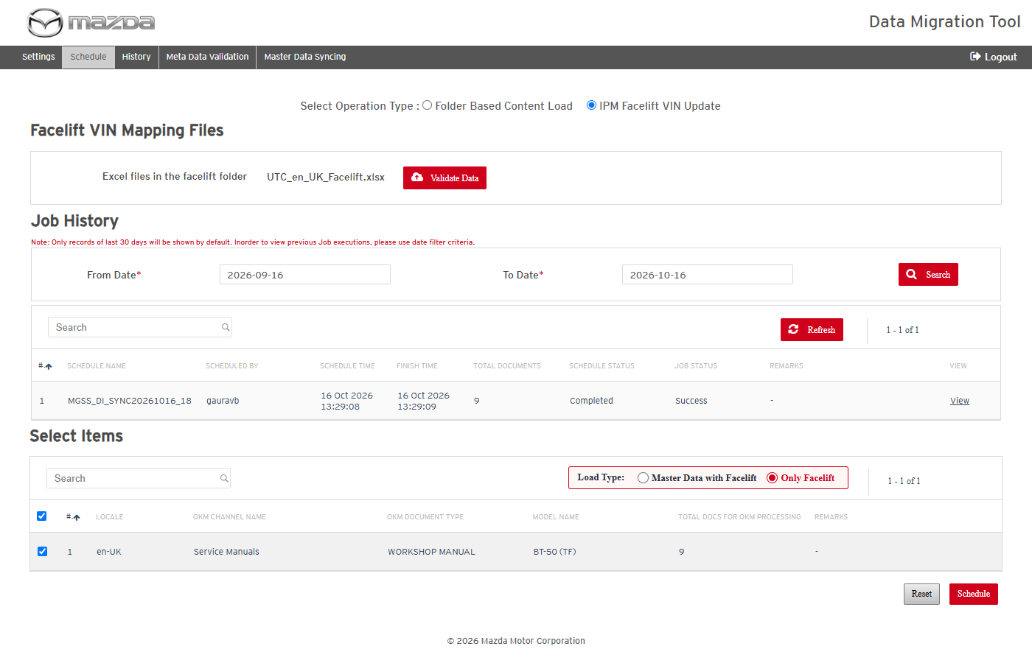
Identified items with load type
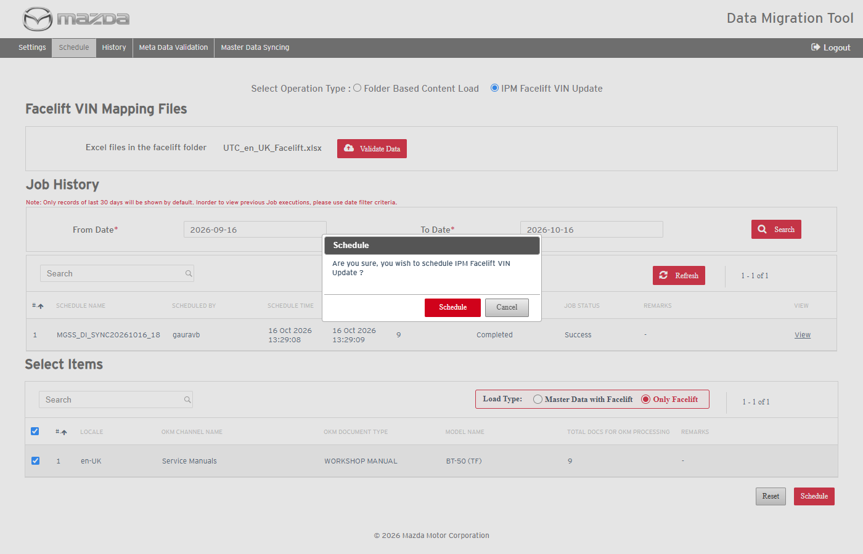
Schedule confirmation
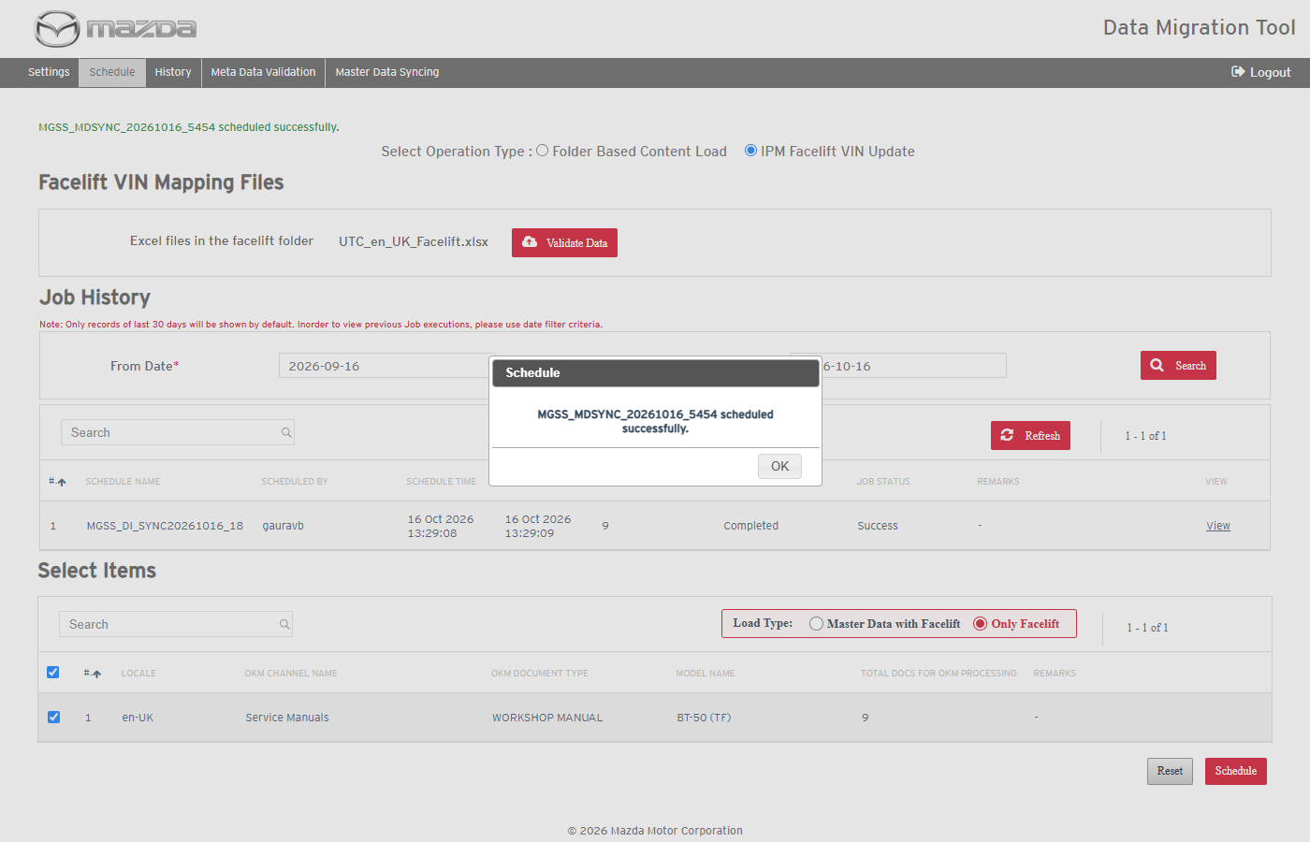
Facelift job scheduled
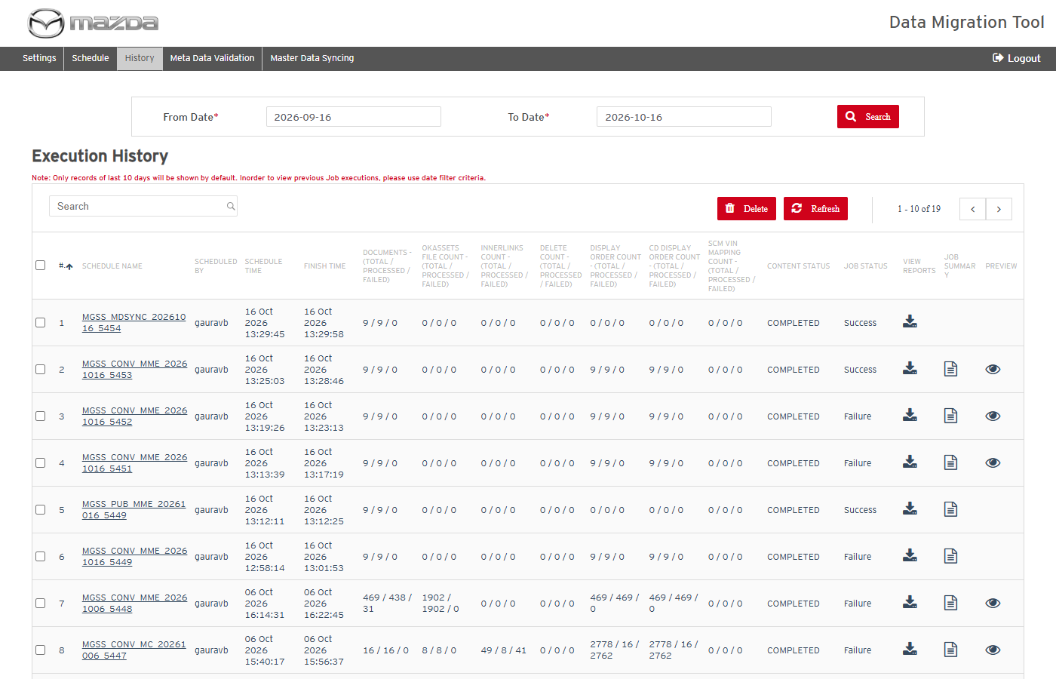
Facelift job COMPLETED - Success
Status: Pass
Remarks:

